

IceCube Maintenance and Operations

**Fiscal Year 2015 Annual Report**

**October 1, 2014 – September 30, 2015**

**Submittal Date: September 30, 2015**

____________________________________

University of Wisconsin–Madison

This report is submitted in accordance with the reporting requirements set forth in the IceCube Maintenance and Operations Cooperative Agreement, ANT-0937462.

**Foreword**

This FY2015 Annual Report is submitted as required by the NSF Cooperative Agreement ANT-0937462. This report covers the 12-month period beginning October 1, 2014 and concluding September 30, 2015. The status information provided in the report covers actual common fund contributions received through March 31, 2015 and the full 86-string IceCube detector (IC86) performance through September 1, 2015.

**Table of Contents**

**Foreword 2**

**Section I – Financial/Administrative Performance 4**

**Section II – Maintenance and Operations Status and Performance 6**

**Detector Operations and Maintenance 6**

**Computing and Data Management 14**

**Data Release 21**

**Program Management 23**

**Section III – Project Governance and Upcoming Events 25**

**Section I – Financial/Administrative Performance**

The University of Wisconsin–Madison is maintaining three separate accounts with supporting charge numbers for collecting IceCube M&O funding and reporting related costs: 1) NSF M&O Core account, 2) U.S. Common Fund account, and 3) Non-U.S. Common Fund account.

A total amount of $6,900,000 was released to UW–Madison to cover the costs of maintenance and operations in FY2015: $914,550 was directed to the U.S. Common Fund account based on the total number of U.S. Ph.D. authors, and the remaining $5,985,450 was directed to the IceCube M&O Core account (Figure 1).

|  |  |
| --- | --- |
| **FY2015** | **Funds Awarded to UW** |
| IceCube M&O Core account | $5,985,450 |
| U.S. Common Fund account | $914,550 |
| **TOTAL NSF Funds** | **$6,900,000** |

**Figure 1: NSF IceCube M&O Funds - FY2015**

Of the IceCube M&O FY2015 Core funds, $915,663 were committed to seven U.S. subawardee institutions. The institutions submit invoices to receive reimbursement against their actual IceCube M&O costs. Figure 2 summarizes M&O responsibilities and total FY2015 funds for the seven subawardee institutions.

|  |  |  |
| --- | --- | --- |
| **Institution** | **Major Responsibilities** | **Funds** |
| Lawrence Berkeley National Laboratory | Data Acquisition maintenance, computing infrastructure | $81,516 |
| Pennsylvania State University | Data acquisition firmware support, simulation production | $71,676 |
| University of California at Berkeley | Detector calibration, monitoring coordination | $80,895 |
| University of Delaware, Bartol Institute | IceTop calibration, monitoring and maintenance | $93,797 |
| University of Maryland at College Park | IceTray software framework, online filter, simulation software | $518,906 |
| University of Alabama at Tuscaloosa | Detector calibration, reconstruction and analysis tools | $45,501 |
| Michigan State University | Simulation software, simulation production | $23,372 |
| **Total** |  | **$915,663** |

**Figure 2: IceCube M&O Subawardee Institutions – FY2015 Major Responsibilities and Funding**

***IceCube NSF M&O Award Budget, Actual Cost and Forecast***

The current IceCube NSF M&O 5-year award was established at the beginning of Federal Fiscal Year 2011, on October 1, 2010. The following table presents the financial status as of August 31, 2015, and shows an estimated balance at the end of FY2015.

Total awarded funds to the University of Wisconsin (UW) for supporting IceCube M&O from the beginning of FY2011 through the end of FY2015 are $34,694K. Total actual cost as of August 31, 2015 is $33,062K; open commitments against purchase orders and subaward agreements are $591K. The current balance as of August 31, 2015 is $1,041K. With a projection of $707K for the remaining expenses during the final one month of FY2015, the estimated unspent funds at the end of FY2015 are $334K, which is 4.8% of the FY2015 budget (Figure 3).

|  |  |  |  |  |  |
| --- | --- | --- | --- | --- | --- |
| **(a)** | **(b)** | **(c)** | **(d)= a - b - c** | **(e)** | **(f) = d – e** |
| **YEARS 1-5 Budget**  Oct.’10-Sep.’15 | **Actual Cost To Date** through  Aug. 31, 2015 | **Open Commitments**  on  Aug. 31, 2015 | **Current Balance**  on  Aug. 31, 2015 | **Remaining Projected Expenses**  through Sept. 2015 | **End of FY2015 Forecast Balance** on Sept. 30, 2015 |
| **$34,694K** | **$33,062K** | **$591K** | **$1,041K** | **$707K** | **$334K** |

**Figure 3: IceCube NSF M&O Award Budget, Actual Cost and Forecast**

The current forecasted balance at the end of the fifth year of the five-year M&O award (FY2015) is expected to be 4.8%, which is less than the allowed 10% annual carryover, according to the M&O Cooperative Agreement.

NSF is planning to extend this five-year award by six months through March 31, 2016. A no-cost extension was approved by NSF and a six-month supplemental funding request is in the process of submission.

***IceCube M&O Common Fund Contributions***

The IceCube M&O Common Fund was established to enable collaborating institutions to contribute to the costs of maintaining the computing hardware and software required to manage experimental data prior to processing for analysis.

Each institution contributed to the Common Fund, based on the total number of the institution’s Ph.D. authors, at the established rate of $13,650 per Ph.D. author. The Collaboration updates the Ph.D. author count twice a year before each collaboration meeting in conjunction with the update to the IceCube Memorandum of Understanding for M&O.

The M&O activities identified as appropriate for support from the Common Fund are those core activities that are agreed to be of common necessity for reliable operation of the IceCube detector and computing infrastructure and are listed in the Maintenance & Operations Plan.

Figure 4 summarizes the planned and actual Common Fund contributions for the period of April 1, 2014–March 31, 2015, based on v16.0 of the IceCube Institutional Memorandum of Understanding, from March 2014. Actual Common Fund FY2015 contributions are $10k less than planned.

|  |  |  |  |  |
| --- | --- | --- | --- | --- |
|  | **Ph.D. Authors** | **Planned Contribution** |  | **Actual Received** |
| **Total Common Funds** | **129** | **$1,776,500** |  | **$1,766,052** |
| U.S. Contribution | 67 | $914,550 |  | $914,550 |
| Non-U.S. Contribution | 62 | $861,950 |  | $851,502 |
|  |  |

Figure 4: Planned and Actual CF Contributions for the period of April 1, 2014–March 31, 2015

###### Section II – Maintenance and Operations Status and Performance

***Detector Operations and Maintenance***

***Detector Performance –*** During the period from July 1, 2014, to September 1, 2015, the full 86-string detector configuration (IC86) operated for 97.72% of the time. Continued operational and software improvements have contributed to increased detector stability and resulted in an unprecedented detector uptime of 99.64%. Figure 1 shows the cumulative detector time usage over the reporting period. The good uptime was 0.79% of the time and includes partial detector (not all 86 strings in operation) analysis-ready data. Excluded uptime includes maintenance, commissioning, and verification data and required 1.14% of detector time. The unexpected detector downtime was limited to 0.36%.

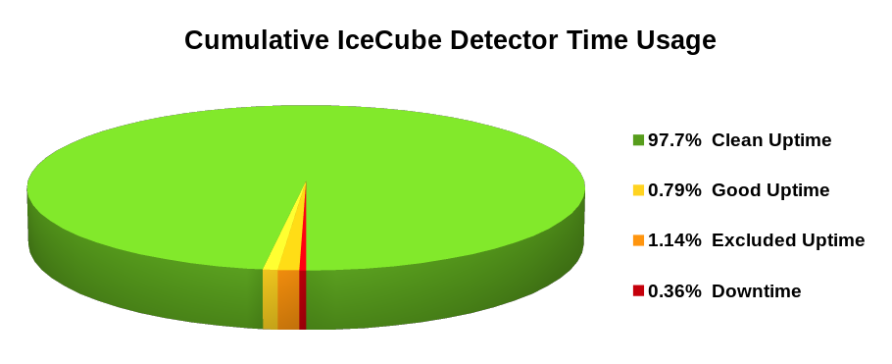

Figure 1: Cumulative IceCube Detector Time Usage, July 1, 2014 – September 1, 2015

The current feature to track portions of failed runs as good, allows the recovery of data from all but the last few minutes of runs that fail, and the recent implementation of continuous data-taking, have improved detector stability and decreased detector downtime. These features increased the average “clean uptime” for this reporting period to 97.7% of full-detector, analysis-ready data, as shown in Figure 2. We are now regularly exceeding our target clean uptime of 95%.

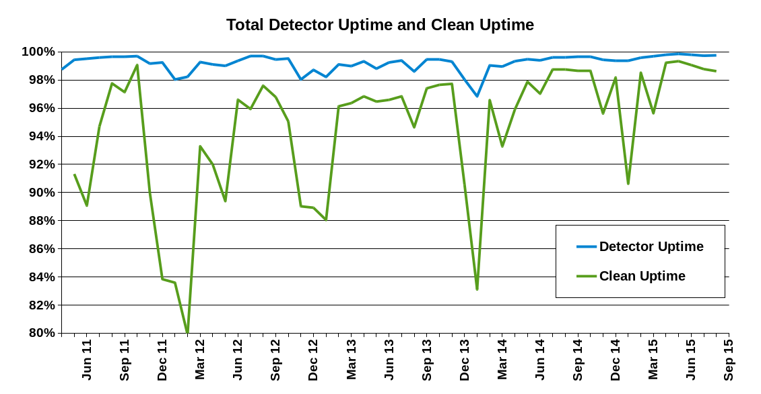

Figure 2: Total IceCube Detector Uptime and Clean Uptime

About 0.2% of the loss in clean uptime is due to the failed portions of runs that are not usable for analysis. There is around 1% of clean uptime loss due to runs not using the full-detector configuration. This occurs when certain components of the detector are excluded from the run configuration during required repairs and maintenance. This data is still good for analyses that have less strict requirements on the active detector volume. There is approximately a 1% loss of clean uptime due to maintenance, commissioning, and verification runs, and short runs that are less than 10 minutes in duration. The experiment control system and DAQ have recently implemented 32-hour periods of continuous data-taking. This new feature has eliminated approximately 90–120 seconds of downtime between each run transition, gaining roughly 0.5% of uptime.

Upcoming improvements include a restructuring of the DAQ functionality so that dropped DOMs can be recovered “in-situ”. This will play in part to allow for continuous data taking to run for longer than the current 32 hour periods. The combined effect will reduce the partial detector configuration time and downtime and increase the clean uptime by at least 0.5%.

The IceCube Run Monitoring system, I3Moni, provides a comprehensive set of tools for assessing and reporting data quality. IceCube collaborators participate in daily monitoring shift duties by reviewing information presented on the web pages and evaluating and reporting the data quality for each run. The original monolithic monitoring system processes data from various SPS subsystems, packages them in files for transfer to the Northern Hemisphere, and reprocesses them in the north for display on the monitoring web pages. In a new monitoring system under development (I3Moni 2.0), all detector subsystems report their data directly to IceCube Live. Major advantages of this new approach include: higher quality of the monitoring alerts; simplicity and easier maintenance; flexibility, modularity, and scalability; faster data presentation to the end user; and a significant improvement in the overall longevity of the system implementation over the lifetime of the experiment.

The I3Moni 2.0 infrastructure for collecting the monitoring data is in place at SPS, and monitoring quantities are now being collected from the four major subsystems: data acquisition (DAQ), supernova DAQ, processing and filtering (PnF), and calibration and verification (CnV). The previous I3Moni 2.0 workshop, held at the University of Maryland in June 2014, focused on test integration and collection of quantities as well as the development and integration of sophisticated quality control systems. Since then 34 issues and requested features have been resolved. The primary improvements include the sending and collecting of the CnV quantities, a fully integrated and comprehensive web display showing all quantities and quality control test results, and a subsystem for storing the data representation and quality control test results for quick web page loading. A workshop will be held the week of September 28, 2015, to resolve any remaining issues in the I3Moni 2.0 alpha release. The I3Moni 2.0 beta release, originally targeted for Fall 2015, is now expected in early 2016.

Development of IceCube Live, the experiment control and monitoring system, is still quite active, and this reporting period has seen four major releases and three patch releases. Individual releases are listed below, along with some of their highlighted features:

* Live v2.6 (August 2014): 41 separate issues and feature requests have been resolved. Multiple improvements to IceCube Live's message transport service were made, including the forwarding of neutrino event data to the north via the low-latency ITS Iridium link to support multi-wavelength follow-up observations. In addition, the IceCube Live web site plotting tools have been entirely refactored, allowing for better analysis and easier maintenance.
* Live v2.7 and v2.8 (October 2014 - April 2015): 91 separate issues and feature requests have been resolved. New features include integration of the IceCube Live low-latency chat service with the popular Slack communication platform, allowing the IceCube winterover operators to participate in a group chat widely used by scientists in the north. Other features include the ability to restart the experiment control portion of IceCube Live without stopping IceCube data-taking. Many user interface improvements were made to facilitate data analysis and support the winterovers' effort. Version 2.8 also includes the alpha release of the I3Moni 2.0 monitoring system.
* Live v2.9 (August 2015): 41 separate issues and feature requests have been resolved. This release introduces a throttling mechanism that prevents services from overloading the experiment control software with monitoring data. Also, as of this release, there is no more need for manual intervention when too many optical modules stop communicating — when this happens, the detector is now reinitialized automatically at the end of its cycle. In addition, more I3Moni 2.0 features were implemented as part of a continuous effort towards the release of the beta version of this new monitoring software.

Features planned for the next few releases include support for the Iridium RUDICS mode, offering lower latency and much higher bandwidth than the SBD Iridium data mode currently used by IceCube Live, and continuing development of I3Moni 2.0. The uptime for the I3Live experiment control system during the reporting period was greater than 99.999%.

The IceCube Data Acquisition System (DAQ) has reached a stable state, and consequently the frequency of software releases has slowed to the rate of 3-4 per year.  Nevertheless, the DAQ group continues to develop new features and patch bugs.  During the reporting period of October 2014–September 2015, the following accomplishments are noted:

* Delivery of the DAQ v4.6 release on January 27, 2015. This release replaces the mix of semi-related operational commands with a unified ‘pdaq’ command for easier use; updates all dependent libraries to their latest versions and eliminates some obsolete dependencies; includes internal monitoring code to track down StringHub problems; and fixes some minor monitoring and continual run bugs.
* Delivery of the DAQ v4.7 release on March 9, 2015.  This release includes optimization of the ClusterTrigger (now 5 times faster) along with system-wide speedup of some core functionality; minor improvements to StringHub; major improvements to the “replay” feature augmented by 8 hours of detector-wide data from back from the South Pole enabling better intra- and inter-system testing of all operations software in the North.
* Delivery of the DAQ v4.8 release on May 11, 2015.  This release includes major improvements to the StringHub to fix time initialization and DOM data bottlenecks; fixes handling of the hub-based directories which cache raw hits (the “HitSpool”); and fixes a few monitoring bugs.
* Delivery of the DAQ v4.9 release on Sep 15, 2015.  This release includes improved time reliability on the hubs; introduction of a new priority-queue based sorter; fixes to the HitSpool code to retain more than two runs of data; and minor monitoring and bug fixes.
* Development toward the next DAQ release which will include extending the time between full detector restarts (to further minimize detector downtime); improved code to recover DOMs which have stopped producing data; further enhancement of the HitSpool caching system; and more work on separating the hub-based data processing from the run-based DAQ system to pare detector downtime to the absolute minimum.

The supernova data acquisition system (SNDAQ) found that 99.11% of the available data from July 1st, 2014 through September 1st, 2015 met the minimum analysis criteria for run duration and data quality for sending triggers. An additional 0.07% of the data is available in short physics runs with less than 10-minute duration. While forming a trigger is not possible in these runs, the data are available for reconstructing a supernova signal.

A new SNDAQ release was installed August 26, 2015. The main change was the switch to new alarm thresholds based on cosmic ray muon-subtracted data, allowing us to improve the detection efficiency for supernovae in the Magellanic Clouds from 12% to 85%.  The CPU and memory consumptions rose by factors of 1.4 and 1.1, respectively, well within the operating margin. In addition, no adverse effect on the latency was observed. As of the time of writing, the new selection runs as an OR with the previous settings based on raw data without muon subtraction. The latter settings will be tightened to decrease the number of observed alarms as the new settings are proven to exhibit the required high level of reliability.

Efforts have started to move the server that manages the alarm handling for SNEWS from a server at the University of Mainz to a central server at UW–Madison. Similarly, in order to further simplify the system, the functionality of two web-based monitoring pages to monitor SNEWS alerts as well as supernova data acquisition runs of the will be integrated into I3Live. The responsibility for the SNEWS monitoring and the I3Moni 2.0 integration has been taken over by a new graduate student at the University of Mainz. A new group from Rochester is joining the efforts and introducing improvements in the maintainability of the SNDAQ software by switching to a new build system that is more in line with other IceCube software and by exploring the option to incorporate the SNDAQ software into IceCube’s IceTray reconstruction framework.

The online filtering system (“PnF”) performs real-time reconstruction and selection of events collected by the data acquisition system and sends them for transmission north via the data movement system.  New software release versions were tested and released to support the test runs for the IC86–2015 physics runs (V15-04-00).  After filter verification and checkout by the collaboration, release V15-05-00 was deployed for the start of the IC86–2015 physics runs, now underway. These releases also add support for DAQ continuous runs, reducing detector deadtime during run transitions.  Current development work is targeted to finalize the I3Moni 2.0 test deployed at pole, support realtime alert generation at Pole, and general software maintenance of the online filtering code, with a release planned for late 2015.

A weekly calibration call keeps collaborators abreast of issues in both in-ice and offline DOM calibration.  Keichii Mase (Chiba University) joined the calibration group as co-convener with Dawn Williams (Univ. of Alabama), and organizes a second call for the calibration work in the Asia/Pacific IceCube institutions. This work includes analysis of data from the in-ice laser calibration device called the standard candle. New standard candle data was collected at the South Pole in January 2015 and is being compared to data from 2012, measuring the stability of the detector.

Online DOM gain corrections using the single photoelectron (SPE) peak were implemented as of the IC86–2015 run transition in May 2015. Figure 3 shows the effect of the correction on the peak of the SPE distribution for each DOM. The mean value of the SPE peak is now at 1 PE, with reduced DOM-to-DOM variation. Support for the updated calibration has been integrated into the IceCube analysis software chain, and the corresponding simulation software has also been corrected and updated in order to improve agreement between simulated and real calibration data.

Additionally, the stability over time of the SPE peak has been investigated, beginning with 2015 data. About one dozen DOMs show sharp, unpredictable changes in gain over time. These DOMs have been documented and are monitored. Figure 4 shows the SPE peak value as a function of time for one of these DOMs, 30-50 “Handen”. The Operations group is developing mitigation strategies to resolve this issue.

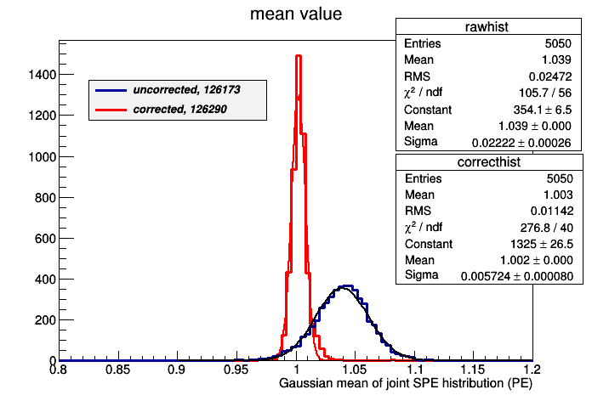

Figure 3: Distribution of the SPE peak value for each DOM, defined as the mean of a Gaussian fit to the peak region of the charge spectrum. Blue: uncorrected, red: corrected. In a correctly calibrated DOM, the peak of the SPE distributions is at 1 PE. The corrected DOM distributions now have a mean value of 1 and the width of the distribution is less than 1%, compared to over 2% before.



Figure 4: SPE peak location as a function of time (represented as run number) for a DOM with gain drift behavior. Approximately 12 of over 5400 DOMs (0.2%) show this type of behavior.

LED flasher calibration data collection continues. A new flasher data acquisition system was developed in summer 2015 in order to collect data from the same PMT as the flashing DOM; in standard operations, the PMT is turned off in the DOM, which contains the active flashers. By reducing PMT gain, we were able to safely collect data in the same PMT, in order to probe the ice immediately surrounding the DOM, especially the properties of the refrozen hole ice. As yet no unambiguous local hole ice signal has been observed. The next phase in this study will be to investigate ice in older IceCube strings where the drilling process produced larger volumes of melted water. Flasher data continues to be used to refine the in-situ description of the DOM angular sensitivity.

Studies using muons to refine our understanding of the in-situ DOM response continue. A new technique uses muons tagged by the two DM-ice scintillator detectors at the bottom of IceCube strings 7 and 79; this allows localization of the muon to within about 10 cm. We are investigating whether we can locate muons that pass close to DOMs using large isolated charge depositions.

The IceTop core group held a workshop in May 2015 at the Bartol Research Institute to develop a revised snow depth correction procedure and implement it in data taken since 2010. The group also worked on producing an official Level 3 (L3) data processing script that unifies the yearly differences in Level 2 (L2). Three years of L2 data has been processed to L3 with snow correction. These data are currently undergoing detailed verification and will be released as official IceTop L3. However, the current snow correction procedure, which works only in the standard IceTop shower reconstruction routine, is not applicable to projects that do not use the standard IceTop reconstructions. A more robust procedure will be developed which works directly on charge pulses, correcting the charge distributions of each DOM according to the snow depth of each tank.

Characterization of the IceTop DOM charge distributions is complex not only due to the gradual snow buildup on tanks, but also due to the seasonal modulations. The tolerance level for each DOM is being optimized and will be implemented in I3Moni 2.0 as alerts for IceTop DOMs. IceTop pulses and the reconstructed observables are now integrated into the standard IceCube event viewer tool, Steamshovel (see Figure 5).

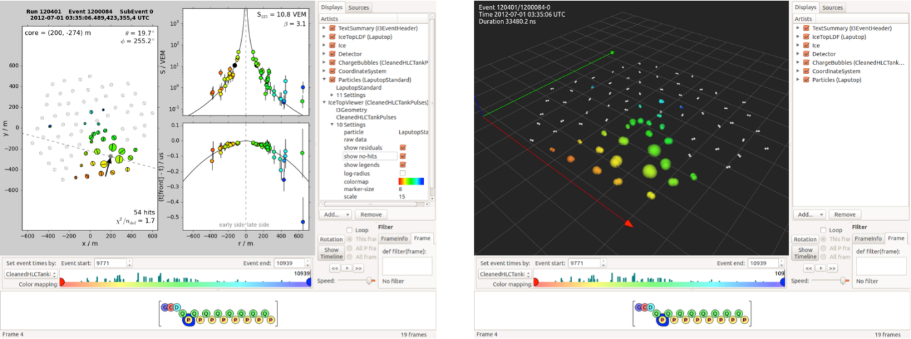

Figure 5: IceTop event views as shown in the Steamshovel viewer. Left: top-down view and shower profile fits. Right: 3D view of the array showing timing and light deposition.

A recent decision by the NSF and the support contractor has been taken to stop any further snow management efforts. With this in mind, we are investigating experimental techniques to restore the full operational efficiency of the IceCube surface component. We plan to deploy plastic scintillator panels on the snow surface above the buried IceTop tanks. Four of these panels have been built, calibrated, and cold tested at UW–Madison; these have shipped for deployment during the 2015–16 pole season (see Figure 6). The initial deployment will use spare tank freeze control cables left in place after deployment in order to read out the scintillator data and connect into the IceCube DAQ, with minimal changes necessary. These prototypes use existing spare DOM mainboards for readout, along with scintillator material donated from the MINOS experiment. Modernization of the electronics will be required for a larger deployment over more IceTop tanks.

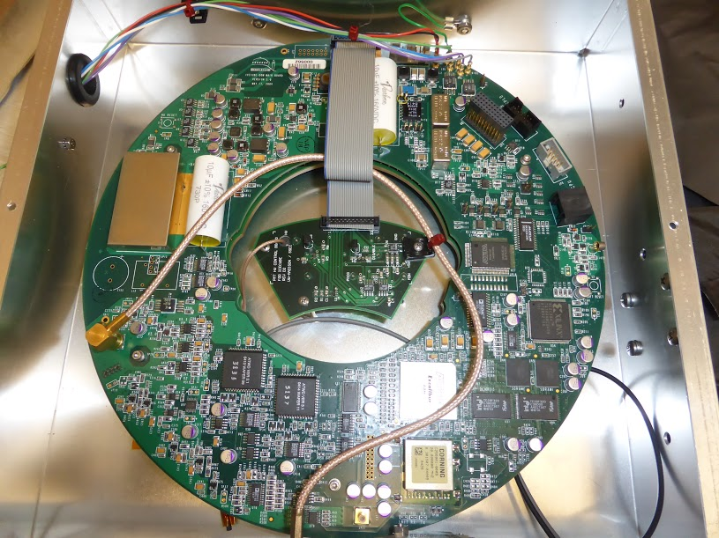 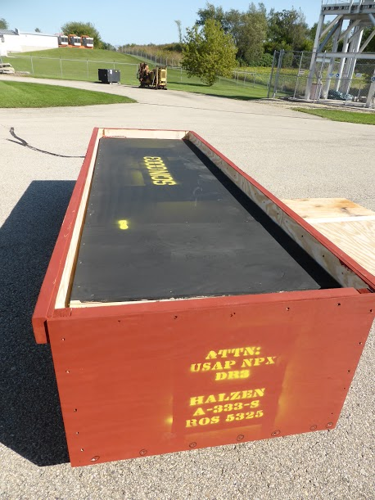

Figure 6: Left: Spare DOM mainboard integrated into a prototype scintillator.   
Right: Modules crated for shipment from UW Physical Sciences Laboratory.

***IC86 Physics Runs –*** The fifth season of the 86-string physics run, IC86–2015, began on May 18, 2015. Detector settings were updated using the latest yearly DOM calibrations from March 2015, and new precision DOM gain calibrations were integrated into the online processing system. DAQ trigger settings did not change from IC86–2014. Filter changes include new starting-event filters as well as a realtime neutrino stream, both of which will be used as follow-up multi-messenger alerts to other observatories. The removal of a minimum-bias component to the full-sky-starting-track filter led to a reduction in average satellite bandwidth usage.

The physics run start in May 2015 also corrected a leap-second issue with IceCube’s GPS master clock, in which a vendor firmware bug introduced an additional leap second 24 hours before the actual leap second in June 2012. This caused a 1-second offset of the IceCube clock relative to UTC. Additional monitoring added in DAQ software now performs cross-checks with an independent time standard to avoid similar problems in the future.

The last DOM failures (2 DOMs) occurred during a power outage on May 22, 2013. No DOMs have failed during this reporting period. The total number of active DOMs remains 5404 (98.5% of deployed DOMs).

***TFT Board –*** The TFT board is in charge of adjudicating SPS resources according to scientific need, as well as assigning CPU and storage resources at UW for mass offline data processing (a.k.a. Level 2). TFT management of the offline processing has resulted in a latency of only 2–4 weeks after data-taking. Working groups within IceCube will submit proposals requesting data processing, satellite bandwidth and data storage, and the use of various IceCube triggers for IC86–2015. Sophisticated online filtering data selection techniques are used on SPS to preserve bandwidth for other science objectives. Over the past three years, new data compression algorithms (SuperDST) have allowed IceCube to send a larger fraction of the triggered events over TDRSS than in previous seasons. The additional data enhances the science of IceCube in the search for neutrino sources from the Southern sky, including the Galactic Center. Furthermore, this compressed stream serves as the archival format for IceCube raw data.

Starting with IC86–2015, we implemented changes to the methodology for producing online quasi-real-time alerts. Neutrino candidate events at a rate of 3 mHz are now sent via Iridium satellite, so that neutrino coincident multiplets (and thus candidates for astrophysical transient sources) can be rapidly calculated and distributed in the northern hemisphere. This change will enable significant flexibility in the type of fast alerts produced by IceCube.

Since the IC86–2015 run start in May, the average TDRSS daily transfer rate is approximately 70 GB/day, reduced from 90 GB/day in IC86-2014 by optimization of online filter settings. IceCube is a heavy user of the available bandwidth, and we will continue to moderate our usage without compromising the physics data.

***Operational Communications –*** Communication with the IceCube winterovers, timely delivery of detector monitoring information, and login access to SPS are critical to IceCube’s high-uptime operations. Several technologies are used for this purpose, including interactive chat, ssh/scp, the IMCS e-mail system, and the IceCube Teleport System (ITS) using a dedicated Iridium modem in short-burst data mode.

Low-bandwidth text chat is used to communicate with the IceCube winterovers to coordinate operations and diagnose problems. Skype has been successfully used for this purpose for many years in IceCube, but during 2014, we were notified of the necessity to stop the use of Skype at the South Pole. Support for Jabber as an alternative has been intermittent and unreliable. We have now implemented our own chat system via I3Live that uses IceCube’s own Iridium connection.

With the TDRSS F5 satellite retirement, the total high-bandwidth satellite coverage was reduced by approximately 6 hours per day, because TDRSS F6 now overlaps with the GOES pass. This significantly reduced the amount of e-mail that could be transmitted over the satellites, and more e-mail traffic had to be moved over the IMCS (Iridium) link. This, combined with issues with a Microsoft Exchange upgrade, has led the contractor to eliminate 24/7 e-mail delivery service except for operational needs. Because IceCube relies on the IMCS link to deliver small quantities of critical monitoring information, a dedicated e-mail queue for this purpose was retained. Nevertheless, we are now developing our own Iridium RUDICS-based transport software and will move IceCube’s monitoring traffic to our own modem(s) in the 2015–16 austral summer season. The technical details of this plan have been reviewed and approved by NSF and the contractor.

***Personnel –*** An open DAQ software developer position was filled in October 2014 by Tim Bendfelt.

***Computing and Data Management***

***Computing Infrastructure –*** IceCube computing and storage systems, both at the Pole and in the north, have performed well over the reporting period. The total amount of data stored on disk in the data warehouse is 3589 Terabytes[1] (TB): 1000 TB for experimental data, 2376 TB for simulation and analysis and 213 TB for user data.

Two large disk expansions were procured and brought online during 2014, providing together about 2200 TB of new disk space. The deployment of these new large disk systems enabled the execution of a very important milestone for the maintenance and operations of the data warehouse: an upgrade of the Lustre software version. Lustre is a distributed filesystem software used for large-scale cluster computing. The IceCube data warehouse relies entirely on this software for providing scalable and high performance data services. Until the start of 2014, all of the production filesystems were using Lustre version 1.8, released in May 2009. The new disk servers were configured with brand new filesystems using the last stable version of Lustre (version 2.5) and this enabled a safe upgrade by means of a massive data migration from the old filesystems to the new ones. This migration was performed transparently for users as data was moved in the background. The migration was completed on June 2015. Since then, all the filesystems in the data warehouse are running an up to date Lustre version that provides richer functionality and improved resiliency. An important outcome of the Lustre upgrade was that it enabled decommissioning old servers (older than 5 years) that were part of this critical infrastructure. The new hardware provides better performance as well as reduced risk of failure.

An additional disk expansion for the data warehouse was procured in June 2015, mostly targeting additional storage for the new data generated by the simulation and analysis processes since the last expansion. The chosen solution consisted of two Dell PowerEdge R430 servers connected to two disk array controllers: one Dell PowerVault MD3460 plus one Dell PowerVault MD3060e expansion, each one holding 60 6TB drives. One of the advantages of this new system is that the controllers provide multipath capability, which allows transparent maintenance operations on the servers. The new systems provide a total usable space of 588 TB.

In 2012, the IceCube Collaboration decided to use direct photon propagation for the mass production of simulation data.  This requires the use of Graphic Processing Units (GPU) hardware to deliver optimal performance. After this decision there was an urgent need in IceCube to quickly ramp up the available GPU capacity. This was highlighted during the IceCube Software and Computing Advisory Panel in April 2014 as one of the higher priority resources needs to focus on.

In September 2014 Nvidia announced the release of the high-end Maxwell architecture GPU card GTX 980, with 2048 cores and 4 GB memory. After confirming its good performance with the IceCube benchmarks, an expansion of the GPU cluster was purchased consisting of 32 SuperMicro 4027GR-TR servers containing a total of 256 GTX 980 GPU cards. The first half of the new servers was deployed in December 2014 and the second half in April 2014.

Figure 8 shows the GPU time delivered per month by the UW-Madison GPU cluster since January 2013. A steady increase in the overall GPU usage can be observed. The big jump in total usage during the first quarter of 2015 corresponds to the deployment of the new 256 Nvidia GTX 980 GPU cards, each of which performs twice as fast as each of the previous generation Nvidia cards.

The GPU expansions in 2013 and 2014 have been deployed as part of the main IceCube cluster at UW-Madison. This way, users can access both resource types, CPUs and GPUs, through the same interface. This simplified access mechanism has had the positive outcome that more collaboration members are now making use of this valuable resource.

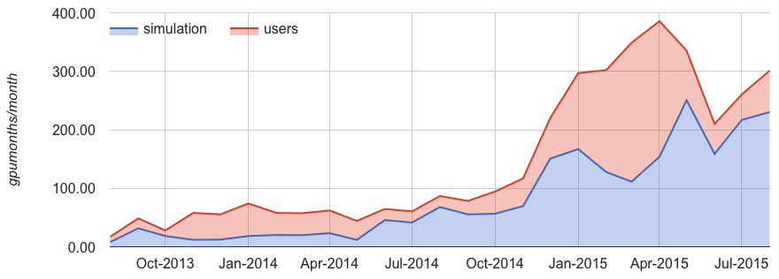

Figure 8: GPU hours consumed by the jobs completing monthly since August 2013 in the IceCube GPU cluster at UW-Madison. The contribution from Simulation Production jobs is shown in blue, and in red the contribution from other IceCube users. The plot units are “normalized GPUs” which correspond to GTX680-equivalent GPUs.

Other sites in the Collaboration are also contributing GPU resources to the Simulation Production (see Figure 9). Several IceCube sites are currently actively working to increase this contribution.

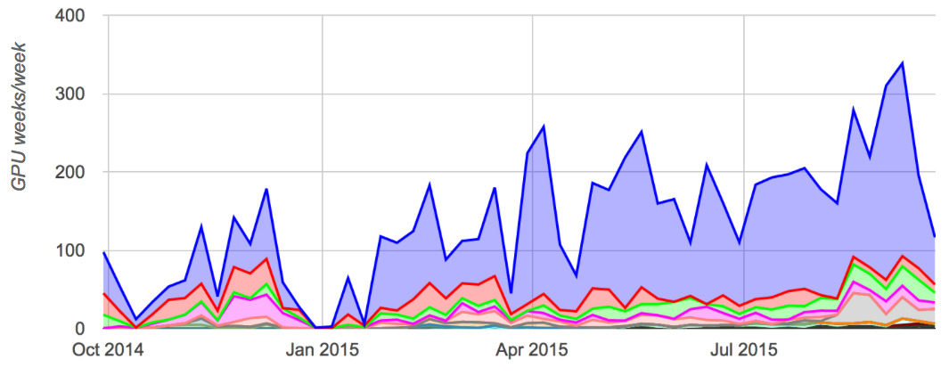

Figure 9: GPU time consumed by IceCube Simulation Production jobs in different clusters. The period displayed spans from 30-Sep-2014 until 21-Sep-2015. The plotted values correspond to normalized GPU weeks consumed per week. The four sites with contributions above 1% are: UW-Madison (76%), UMD (10%), Westgrid Canada (5%) and DESY Zeuthen (5%).

***South Pole System*** – One of the main activities carried out during the 2014-15 South Pole season was the installation of remotely controlled, fully redundant Power Distribution Units (PDU) in the IceCube Lab (ICL). These PDUs allow operators to power cycle unresponsive components from the main station without having to go out to the ICL which is located about 1 km away from the station. This is especially important for DOMHubs, the custom built systems that provide power to the detector strings and handle raw data read-out. Failure of a single DOMHub results in data loss for an entire string, equaling 60 photo sensors. The deployment of remotely controlled PDUs enables reducing partial detector downtime for these events from about one hour to only a few minutes.

After successfully operating the new disk based archival test setup at the South Pole for one year, the entire data archival system was upgraded during the 2014-15 South Pole season. The unreliable tape drives were decommissioned and were replaced by a hard disk based archival system. Three new disk enclosures providing 12 hot-swappable 4TB hard drive slots each are now used to archive the IceCube data.

Other activities carried out at Pole during the 2014-15 season were the installation of a new infrared sky camera on the roof of the ICL to study long-term cloud coverage as part of an evaluation for future experiments. Muon taggers were temporarily installed and test data recorded to study the feasibility of modifying the IceTop detector system during the 2015-16 season. A full 8hrs worth of unfiltered raw data was extracted from the readout systems and was transported North to be used to simulate full 86-string real-time detector response at the South Pole Test System (SPTS) facility at UW-Madison.

A new RUDICS based Iridium system was installed in the ICL to evaluate the possibilities of transporting high-priority detector monitoring data 24/7 in almost real-time. Software developments and testing have been carried out during 2015 and a fully operational RUDICS system is scheduled to be commissioned during the 2015-16 season.

Another activity planned for the 2015-16 season is the upgrade of the network firewall at SPS. The systems currently in production are more than 5 years old, so their replacement this season will reduce the risk of failure of this component. A thorough evaluation of three different options was carried out in the SPTS: a Linux host-based firewall, a CISCO ASA 55112-X and a Dell SonicWall NSA 3600. The selected system was the Dell SonicWall because it presented a number of advantages and lower price given the specifications. Besides that, the new system provides important functionality improvements such as a better high-availability configuration that will enable zero downtime maintenance operations or a very powerful Graphical User Interface that will ease the training process for the winterovers and the on-site operation.

In February 2015 the network configuration in the SPTS was improved in order to provide important new functionality. The new network setup allows to temporarily increase the size of the Processing and Filtering test cluster by adding nodes from the offline-processing cluster, enabling more realistic testing conditions when full capacity is needed.

***Data Reprocessing -*** At the end of 2012, the IceCube Collaboration agreed to store the compressed SuperDST as part of the long-term archive of IceCube data. The decision taken was that this change would be implemented from the IC86-2011 run onwards. A server, a small tape library for output, and a partition of the main tape library for input were dedicated to this data reprocessing task. Raw tapes are read to disk and the raw data files processed into SuperDST. A copy is saved in the data warehouse and another is written to LTO5 tapes for long term archive. During the reporting period, the system to translate raw tapes into SuperDST files was modified to use the Iceprod framework, to streamline operations and allow access to a greater resource pool. Reprocessing was stopped for two months to avoid stepping on the data migration into the new Lustre 2.5 filesystems. The process was restarted early March 2015 under the new framework, which is currently processing about 2400 files/day. We expect to ramp this up to 4000 files/day in the next few days. The plan is to wrap up the project before the end of the year.

***Distributed Computing –*** One of the high level goals within the IceCube computing services is increasing the use of distributed computing (Grid) resources. Facilitating the access to these resources to all the Collaboration members is one of the actions towards that goal. With this objective, a CernVM-Filesystem[2] (CVMFS) repository has been deployed at UW–Madison hosting the IceCube offline software stack, photonic tables and detector conditions data needed for simulation, reconstruction and analysis. CVMFS enables seamless access to the IceCube software from any computer anywhere in the world by means of HTTP. High scalability and performance can be accomplished by deploying a network of standard web caches.

During the last quarter of 2014, the IceCube repository was consolidated into the Open Science Grid (OSG) CVMFS distribution. This allowed IceCube to make use of the content distribution network that the OSG project was rolling out in coordination with the European Grid Infrastructure (EGI) project. Through this mechanism, the IceCube software is currently being mirrored from the BNL and FNAL DOE National Laboratories in the US, from NIKHEF and RAL in Europe and from ASGC in Taiwan. This software distribution infrastructure provides an enormous scalability and resilience for IceCube to ramp up its usage of distributed resources.

Another important aspect of simplifying the user access to Grid resources is to try and present the several heterogeneous clusters in an as unified as possible way. To pursue this, IceCube makes use of some of the federation technologies within HTCondor[3] such as Flocking or GlideinWMS. These allow presenting users many heterogeneous clusters as if they were one big cluster with a single interface. Opportunistic resources at other UW-Madison departments and in Grid sites across the US, Canada and Europe are accessed this way.

Figure 10 shows the CPU time consumed by IceCube jobs in opportunistic distributed resources. A relatively constant use by the Simulation Production activities (in blue) is observed and, on top of that, large peaks in users activity (in red) that show the potential of tapping very large amounts of CPU from this type of resources. In January for instance, the CPU time used by IceCube jobs in opportunistic distributed resources was equivalent to more than 5600 simultaneous jobs continuously running for one month.

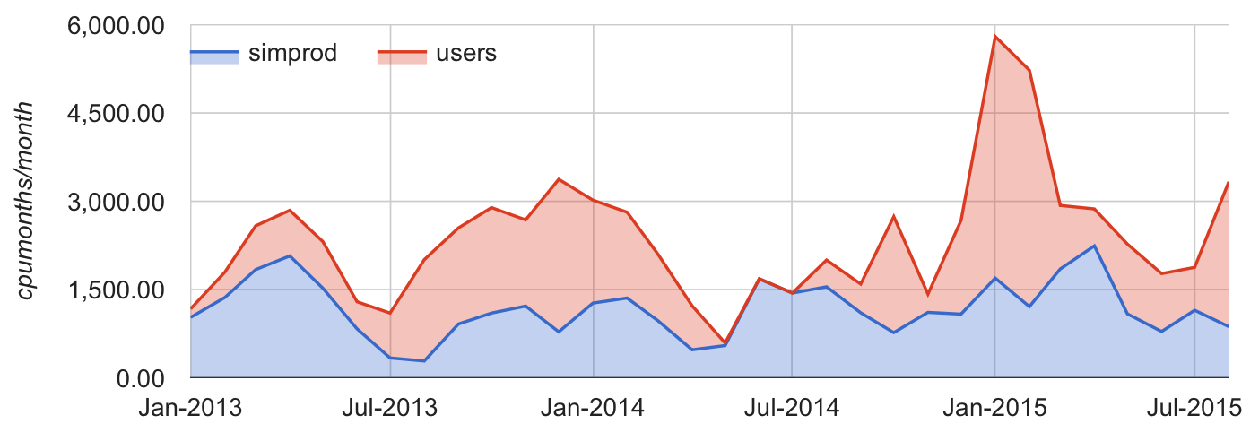

Figure 10: CPU time used by IceCube jobs in opportunistic resources accessed via the Grid. These resources are mostly clusters from other departments at UW-Madison and OSG sites elsewhere in the US. The color code indicates the amount of resources that were used by Simulation Production (blue) as compared to normal users jobs (red).

For those remote clusters that do not provide any access interface other than SSH, IceCube plans to leverage on the Glidein HTCondor technology to build a lightweight pilot job submission service that can then be used to federate these resources. A prototype is being developed and tested and is currently handling Simulation Production jobs submission to the Jasper and Guillimin clusters from the Canadian national compute infrastructure for research as well as to the OSGConnect[4] and XSEDE/OSG infrastructures. The integration of more clusters via this Glidein infrastructure is an ongoing activity.

One of the most critical services in a distributed computing system is the data access. In order to efficiently benefit from potentially very large opportunistic computing capacity peaks, the service at UW-Madison that feeds the input data to those processes and ingests the outputs has to scale accordingly. IceCube data at UW-Madison can be remotely accessed with high performance by means of two main protocols: gridftp and http. The network path connecting the UW-Madison datacenter to the Internet had been capped to 4Gbps for a long time due to an internal network module configuration. As WAN data rates kept growing the cap became more visible and, eventually, an actual bottleneck. In January 2015, this limitation was removed and the external connectivity bandwidth of the UW-Madison datacenter increased to 10Gbps. In April 2015, the maximum capacity of this link was again increased when the science traffic was split from the commodity Internet traffic and re-routed via a new 20Gbps link.

***Data Movement –*** Data movement has performed nominally over the past year. Figure 12 shows the daily satellite transfer rate and weekly average satellite transfer rate in GB/day through August 2015. The run transition in May 2015 is clearly visible in the plot as a decrease in the average daily transfer rate. As reported in the Detector Operations and Maintenance section, this reduction was enabled by the optimization of the online filter settings for the new run. The IC86 filtered physics data are responsible for 95% of the bandwidth usage. A total of 28.8 TB of data were sent over TDRSS, averaging 87.9 GB/day.

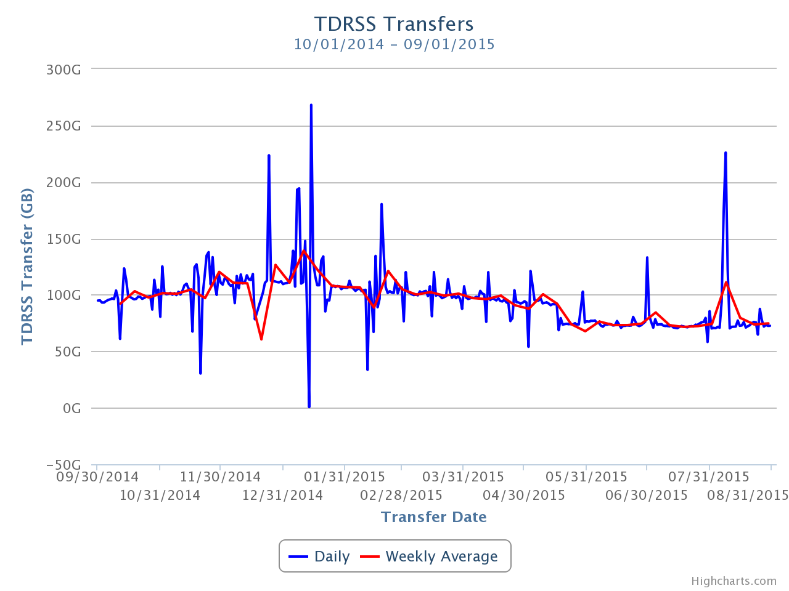

**Figure 12: TDRSS Data Transfer Rates, October 1, 2014–September 1, 2015. The daily transferred volumes are shown in blue and, superimposed in red, the weekly average daily rates are also displayed.**

***Data Archive –*** The IceCube raw data were archived on LTO4 data tapes until October 2014. In October 2014, archival was switched to a new disk archival system. A total of 8.8 TB of data were written to LTO4 tapes during the reporting period (October 2014 to September 2015). A total of 332.4 TB of data were archived to disk, averaging 1.0 TB/day.

The possibility of partnering with the National Energy Research Scientific Computing Center (NERSC) at Lawrence Berkeley National Laboratory (LBNL) for archiving data is being explored. Curating a multi-petabyte tape archive for many years is an activity that entails a number of very specialized operational procedures. One example of these would be the periodic tape media migration that must be done to avoid losing data when tapes age or when technologies become obsolete. The goal of this exploration is to evaluate whether IceCube can implement this long-term archive functionality using a storage facility external to the UW-Madison data center. The main motivation is to aim for a better service at lower cost, since large facilities that routinely manage data at the level of 100 petabytes benefit of economies of scale that ultimately make the process more efficient and economical. A Memorandum of Understanding between UW-Madison and NERSC is currently being drafted that will describe the scope and resources required to implement and operate this service in the following years.

***Offline Data Filtering –*** Data processing for the IC86-2014 season concluded with no issues few days after the run transition in May. A total of 379 days (1683 runs) were processed out of which 369 days were tagged as “good” live time. The IceRec software release used for the data processing was IC2014-L2_V14-02-00.

The data collection for the IC86-2015 season started in May 18 2015. A new compilation of data processing scripts had been previously validated and benchmarked with the data taken during the 24-hour test run using the new configuration. The differences with respect to the IC86-2014 season scripts are minimal, therefore we estimate that the resources required for the offline production will be of about 750,000 CPU hours on the IceCube cluster at UW-Madison datacenter. 120TB of storage is required to store both the Pole-filtered input data and the output data resulting from the offline production. Replication of all the data at the DESY-Zeuthen collaborating institution is being done in a timely manner comparable to previous seasons. Further checks of the data integrity during replication have added an extra layer of validation to the offline production process.

Much progress has been made on the proposed effort to adopt the tools currently employed by the centralized offline production in the post-offline data processing for the various physics analysis groups. This transition enables the efficient automation and monitoring of production. It also ensures better coordination and improvement in resource management and planning. After multiple successful tests, the three main physics analysis groups in the collaboration have now adopted this framework that facilitates producing Level3 data products in a shorter time scale and using consistent procedures with Level2 production in terms of cataloging and bookkeeping.

***Simulation –*** The production of IC86 Monte Carlo began in mid-2012 with simulations of the IC86-2011 detector configuration. A transition to a combined production of IC86-2012, and IC86-2013 simulation started at the beginning of 2014, and direct generation of Level 2 simulation data is now used to reduce storage space requirements. This transition also included a move to a new release of the IceCube simulation software release, IceSim 4. IceSim 4 contains improvements to low-level DOM simulation, correlated noise generation, Earth modeling, and lepton propagation. We have progressed toward having 100% of all simulations based on direct photon propagation using GPUs or a hybrid of GPU and photon look-up tables for high-energy events. Producing simulations of direct photon propagation using GPUs began with a dedicated pool of computers built for this purpose in addition to the standard CPU-based production. Benchmark performance studies of consumer-class GPU cards have been completed and provided to the collaboration as we scale up the available GPUs for simulation. In 2015, we began transitioning to generating IC86-2014 datasets and halt production of IC86-2012, and IC86-2013 given that the detector configuration and level2 reconstructions are very similar and representative of all three years.

The simulation production sites are: CHTC – UW campus (including GZK9000 GPU cluster); Dortmund; DESY-Zeuthen; University of Mainz; EGI – German grid; WestGrid – U. Alberta; SWEGRID – Swedish grid; PSU – Pennsylvania State University; LONI – Louisiana Optical Network Infrastructure; GLOW – Grid Laboratory of Wisconsin; UMD – University of Maryland; RWTH Aachen; IIHE – Brussels; UGent – Ghent; Ruhr-Uni – Bochum; UC Irvine; Michigan State University - ICER; The Extreme Science and Engineering Discovery Environment (XSEDE); Niels Bohr Institute, Copenhagen Denmark; PDSF/Carver/Dirac – LBNL; and NPX – UW IceCube.

***Personnel –*** The Simulation Production team has an open position as of September 2015 for a software developer to work on the maintenance and development of software for experimental data processing and simulation production on the Grid as well as of tools to monitor and validate this processing. The IT team also has an open position as of September 2015 for a Linux system administrator to manage the storage services in the UW-Madison datacenter.

***Data Release***

***Data Use Policy*** –IceCube is committed to the goal of releasing data to the scientific community. The following links contain data sets produced by AMANDA/IceCube researchers along with a basic description. Due to challenging demands on event reconstruction, background rejection and systematic effects, data will be released after the main analyses are completed and results are published by the international IceCube Collaboration.

***Datasets (last release on 20 Aug 2015): http://icecube.wisc.edu/science/data***

The pages below contain information about the data that were collected and links to the data files.

Astrophysical muon neutrino flux in the northern sky with 2 years of IceCube data

https://icecube.wisc.edu/science/data/HE_NuMu_diffuse

IceCube-59: Search for point sources using muon events:

https://icecube.wisc.edu/science/data/IC59-point-source

Search for contained neutrino events at energies greater than 1 TeV in 2 years of data:

<http://icecube.wisc.edu/science/data/HEnu_above1tev>

IceCube Oscillations: 3 years muon neutrino disappearance data:

<http://icecube.wisc.edu/science/data/nu_osc>

Search for contained neutrino events at energies above 30 TeV in 2 years of data:

<http://icecube.wisc.edu/science/data/HE-nu-2010-2012>

IceCube String 40 Data:

<http://icecube.wisc.edu/science/data/ic40>

IceCube String 22–Solar WIMP Data:

<http://icecube.wisc.edu/science/data/ic22-solar-wimp>

AMANDA 7 Year Data:

<http://icecube.wisc.edu/science/data/amanda>

***Program Management***

***Management & Administration*** –The primary management and administration effort is to ensure that tasks are properly defined and assigned and that the resources needed to perform each task are available when needed. Efforts include monitoring that resources are used efficiently to accomplish the task requirements and achieve IceCube’s scientific objectives.

* The FY2015 M&O Plan was submitted in January 2015.
* The detailed M&O Memorandum of Understanding (MoU) addressing responsibilities of each collaborating institution was revised for the collaboration meeting in Madison, WI, April 28 – May 2, 2015.

Starting from September 2014, Professor Kael Hanson of the Université Libre de Bruxelles, succeeded Jim Yeck as Director of WIPAC and Director of IceCube Maintenance and Operations.

### IceCube M&O - FY2015 Milestones Status:

|  |  |
| --- | --- |
| **Milestone** | **Month** |
| Revise the Institutional Memorandum of Understanding (MOU v17.0) - Statement of Work and Ph.D. Authors head count for the fall collaboration meeting | **September 2014** |
| Report on Scientific Results at the Fall Collaboration Meeting | **Sept 14-19, 2014** |
| Submit for NSF approval, a revised IceCube Maintenance and Operations Plan (M&OP) and send the approved plan to non-U.S. IOFG members. | **January 2015** |
| Annual South Pole System hardware and software upgrade is complete. | **January 2015** |
| Submit to NSF a mid-year interim report with a summary of the status and performance of overall M&O activities, including data handling and detector systems. | **March 2015** |
| Revise the Institutional Memorandum of Understanding (MOU v18.0) - Statement of Work and Ph.D. Authors head count for the spring collaboration Meeting | **April 2015** |
| Post the revised institutional MoU’s and Annual Common Fund Report and notify IOFG. | **April 2015** |
| Report on Scientific Results at the Spring Collaboration Meeting | **Apr 28 - May 2, 2015** |
| IceCube IOFG Meeting | **May 3, 2015** |
| Submit for NSF approval an annual report which will describe progress made and work accomplished based on objectives and milestones in the approved annual M&O Plan. | September 2015 |
| Revise the Institutional Memorandum of Understanding (MOU v19.0) - Statement of Work and Ph.D. Authors head count for the fall collaboration meeting | October 2015 |

***Engineering, Science & Technical Support*** –Ongoing support for the IceCube detector continues with the maintenance and operation of the South Pole Systems, the South Pole Test System, and the Cable Test System. The latter two systems are located at the University of Wisconsin–Madison and enable the development of new detector functionality as well as investigations into various operational issues, such as communication disruptions and electromagnetic interference. Technical support provides for coordination, communication, and assessment of impacts of activities carried out by external groups engaged in experiments or potential experiments at the South Pole.

***Education & Outreach (E&O)*** – The following four areas form the basis for ongoing collaboration-wide E&O efforts:

1. Reaching motivated high school students and teachers through IceCube Masterclasses
2. Providing intensive research experiences for teachers and undergraduates through PolarTREC and NSF funding
3. Supporting the IceCube Collaboration’s education and outreach efforts through web and print resources, graphic design, webcasts with IceCube staff at the Pole, and displays
4. Developing and implementing semiannual communication skills workshops held in conjunction with IceCube Collaboration meetings

The second IceCube Masterclass was held in March, 2015, and doubled the number of institutions that participated from five in the first year to ten this year. Approximately 175 students participated. Hans Dembinski at the University of Delaware developed a new cosmic ray analysis activity, and presented a poster and submitted a contribution on this effort at the 2015 International Cosmic Ray Conference at The Hague, Netherlands. IceCube collaborators have also translated the masterclass content into German. We are currently promoting the 2016 masterclass to attract more students, involve more collaborators, and increase the quality and variety of the topics available.

PolarTREC teacher Armando Caussade deployed to the South Pole with IceCube, took measurements on IceTop, and participated in three webcasts. He also blogged about his experience in both Spanish and English and received extensive media coverage in Puerto Rico and elsewhere. Armando has incorporated his Antarctic experience into after-school programs for elementary school children and college-level introductory astronomy classes. He also contributed to the UW-River Falls Upward Bound program (July 6-16, 2015) where he helped teach math and science along with former IceCube PolarTREC teachers Liz Ratliff and Katey Shirey and long-time teacher Steve Stevenoski. We were not able to host another teacher in the upcoming 2015-16 season because of South Pole population constraints. An application to host a teacher in 2016-17 has been submitted to the PolarTREC program.

NSF International Research Experience for Students (IRES) funding supported four students (three women) in the summer of 2015 in Germany, two in Bochum and two at Mainz. The students came from three US IceCube institutions, two from UW–River Falls and one each from UW–Madison and the University of Kansas. UW–River Falls received NSF Research Experience for Undergraduates funding for 18, ten-week summer experiences over three summers. In total, UW–River Falls had 13 undergraduate students working on astrophysics projects in the summer of 2015, 12 of whom attended the WIPAC IceCube boot camp along with students from UW–Madison, Yale, Georgia Tech, and the University of Alabama.

The new IceCube scale model with one colored LED for each of the 5,160 DOMs has been completed. It has an iPad interface that allows users to select different types of events and that also provides background information about the detector and the detection of neutrinos and cosmic rays. New features are sound to enhance the experience and an interface to Steamshovel, the event viewer software used by IceCube researchers. Digital and print resources are regularly updated and include a new brochure that can be personalized as desired by IceCube collaborators.

At the spring 2015 IceCube Collaboration meeting in Madison, we launched a communication training program targeting PhD students and postdocs. The goal is to help them develop skills to reach all types of audiences, from journalists to science-skeptical and lay audiences. The first workshop focused on understanding your audience and was attended by 20 collaborators. The workshop scheduled for the fall collaboration meeting in Denmark will focus on developing experience-based learning activities.

Finally, we have increased the dissemination of IceCube E&O efforts. We presented talks on the E&O program at the Scientific Conference on Antarctic Research meeting in New Zealand (August 2014), the American Geophysical Union (AGU) Fall Meeting in San Francisco (December 2014), the International Teacher-Scientist Partnership Conference in San Francisco (February 2015), and the Broader Impact Summit in Madison (April 2015). Posters were presented on the masterclass at the AGU Fall Meeting in San Francisco (December 2014) and on the new cosmic ray masterclass at the 34th International Cosmic Ray Conference in The Hague (August 2015).

The E&O team works closely with the communication team. Science news summaries of IceCube publications, written at a level accessible to science-literate but non-expert audiences, continue to be produced and posted regularly on the IceCube website and highlighted on social media.

**Ongoing local E&O efforts -** Two examples of the extensive WIPAC E&O efforts beyond the four core areas of collaboration-wide E&O include:

i) High School Internship Program—A dozen postdocs and graduate students mentor about 25 area high school students for ten-week internships during the school year and seven-week internships during the summer. The high school interns use data from real physics experiments to learn about topics in astrophysics, computer programming, and data processing.

ii) Science Alliance—WIPAC is an active member in the Science Alliance, a group of researchers, outreach professionals, and volunteers from UW–Madison and the community. Each year, this group organizes and hosts several science festivals and activities in Madison and around Wisconsin that allow us to talk about IceCube to thousands of people every year.

**Section III – Project Governance and Upcoming Events**

The detailed M&O institutional responsibilities and Ph.D. author head count is revised twice a year at the time of the IceCube Collaboration meetings. This is formally approved as part of the institutional Memorandum of Understanding (MoU) documentation. The MoU was last revised in April 2015 for the Spring collaboration meeting in Madison, WI (v18.0), and the next revision (v19.0) will be posted in October 2015 at the Fall collaboration meeting in Copenhagen, Denmark.

***IceCube Collaborating Institutions***

Following the September 2014 Fall collaboration meeting, the Drexel University with Dr. Naoko Kurahashi Neilson as the institutional lead, and Michigan State University with Dr. Tyce DeYoung as the institutional lead, were approved as full members of the IceCube Collaboration. After the May 2015 collaboration meeting, the Massachusetts Institute of Technology with Janet Conrad as the institutional lead was approved as a full member of IceCube.

FOREWARN, a proposal to investigate the effects of interplanetary magnetic fields on high energy cosmic rays using IceCube data, Andrew Erlandson (CNL, Chalk River, Canada) and John Armitage (Carleton University, Ottawa, Canada) applied for associate membership sponsored by Darren Grant, and was approved by the IceCube Collaboration.

As of September 2015, the IceCube Collaboration consists of 45 institutions in 12 countries (23 U.S. and 18 Europe and 4 Asia Pacific).

The list of current IceCube collaborating institutions can be found on:

http://icecube.wisc.edu/collaboration/institutions

***IceCube Major Meetings and Events***

National Academies of Sciences Study on Strategic Vision FOR USAP October 21, 2014

IceCube Spring Collaboration Meeting – Madison, WI April 28 – May 2, 2015

IceCube IOFG Meeting – Madison, WI May 3, 2015

IceCube Particle Astrophysics Symposium – UW–Madison May 4-6, 2015

IceCube Fall Collaboration Meeting – Copenhagen, Denmark October 12-16, 2015

IceCube Science Advisory Committee (SAC) Meeting, Madison, WI October 19-20, 2015

Software & Computing Advisory Panel (SCAP) Review, Madison, WI March / April, 2016

IceCube Spring Collaboration-Columbia, Stony Brook, New York April 16-22, 2016

# Acronym List

CnV Calibration and Verification

CVMFS CernVM-Filesystem

DAQ Data Acquisition System

DOM Digital Optical Module

E&O Education and Outreach

I3Moni IceCube Run Monitoring system

IceCube Live The system that integrates control of all of the detector’s critical subsystems; also “I3Live”

IceTray IceCube core analysis software framework, part of the IceCube core software library

MoU Memorandum of Understanding between UW–Madison and all collaborating institutions

PMT Photomultiplier Tube

PnF Processing and Filtering

SNDAQ Supernova Data Acquisition System

SPE Single photoelectron

SPS South Pole System

SuperDST Super Data Storage and Transfer, a highly compressed IceCube data format

TDRSS Tracking and Data Relay Satellite System, a network of communications satellites

TFT Board Trigger Filter and Transmit Board

WIPAC Wisconsin IceCube Particle Astrophysics Center

1. 1 Terabyte = 1012 bytes
2. http://cernvm.cern.ch/portal/filesystem
3. http://research.cs.wisc.edu/htcondor/
4. http://osgconnect.net/