

IceCube Maintenance and Operations

**Fiscal Year 2012 Annual Report**

**October 1, 2011 - September 30, 2012**

**Submittal Date: September 13, 2012**

____________________________________

University of Wisconsin–Madison

This report is submitted in accordance with the reporting requirements set forth in the IceCube Maintenance and Operations Cooperative Agreement, ANT-0937462.

**Foreword**

This FY2012 End Year Report is submitted as required by the NSF Cooperative Agreement ANT-0937462. This report covers the 12-month period beginning October 1, 2011, and concluding September 30, 2012. The status information provided in the report covers actual common fund contributions received through August 31, 2012, and the full 86-string IceCube detector (IC86) uptime through September 1, 2012.

**Table of Contents**

**Foreword 2**

**Section I – Financial/Administrative Performance 4**

**Section II – Maintenance and Operations Status and Performance 6**

**Detector Operations and Maintenance 6**

**Computing and Data Management 13**

**Data Release 15**

**Program Management 16**

**Section III – Project Governance and Upcoming Events 20**

**Section I – Financial/Administrative Performance**

The University of Wisconsin–Madison is maintaining three separate accounts with supporting charge numbers for collecting IceCube M&O funding and reporting related costs: 1) NSF M&O Core Account; 2) U.S. Common Fund Account; and, 3) Non-U.S. Common Fund Account.

A total of $6,900,000 was released to UW–Madison to cover the costs of Maintenance and Operations during FY2012. A total of $941,850 was directed to the U.S. Common Fund Account and the remaining $5,958,150 was directed to the IceCube M&O Core Account (Figure 6).

|  |  |
| --- | --- |
| **FY2012** | **Funds Awarded to UW** |
| IceCube M&O Core account | $5,958,150 |
| U.S. Common Fund account | $941,850 |
| **TOTAL NSF Funds** | **$6,900,000** |

**Figure 6: NSF IceCube M&O Funds**

A total amount of $1,790,000 of the IceCube M&O FY2012 Core funds were committed to six U.S. Institutions via Subawards. The Institutions submit invoices to receive reimbursement against their actual IceCube M&O costs. Deliverable commitments made by each Institution are monitored throughout the year. Figure 7 summarizes M&O responsibilities and total FY2012 funds for the six institutions receiving Subawards from UW-Madison.

|  |  |  |
| --- | --- | --- |
| **Institution** | **Major Responsibilities** | **FY2012** |
| Lawrence Berkeley National Laboratory | Detector verification, detector calibration | $63k |
| Pennsylvania State University | Detector verification, high-level monitoring and calibration. | $36k |
| University of California at Berkeley | Calibration, monitoring, ice model development | $137k |
| University of Delaware, Bartol Institute | IceTop surface array calibration, monitoring, and simulation | $170k |
| University of Maryland at College Park | Support IceTray software framework, online filter, simulation production, spokesperson | $1,185k |
| University of Wisconsin–River Falls | Education & Outreach coordination and related activities | $199k |
| **Total** |  | **$1,790k** |

**Figure 7: IceCube M&O Subawardee Institutions - Major Responsibilities and Funding**

***IceCube NSF M&O Award Budget, Actual Cost and Forecast***

The current IceCube NSF M&O 5-year award was established on October 1, 2010, at the beginning of Federal Fiscal Year 2011. A total of $13,800K was awarded to the University of Wisconsin (UW) for supporting FY2011 and FY2012 .

At the end of August 2012, eleven months into FY2012, the total actual cost to date was $10,890K with an open commitment of $1,320K. The remaining estimated expenses in September 2012 are $544K. The forecasted balance at the end of FY2012 is $1,047K which is 15.2% of FY2012 $6,900K budget.

Figure 8 summarizes the current financial status on August 31, 2012 and the estimated balance at the end of FY2012.

|  |  |  |  |  |  |
| --- | --- | --- | --- | --- | --- |
| **(a)** | **(b)** | **(c)** | **(d)= a - b - c** | **(e)** | **(f) = d – e** |
| **YEARS 1+2 Budget**  Oct.’10-Sep.’12 | **Actual Cost To Date** through  Aug. 31, 2012 | **Open Commitments**  on  Aug. 31, 2012 | **Current Balance**  on  Aug. 31, 2012 | **Remaining Expenses Forecast**  in Sept. 2012 | **End of FY2012 Forecast Balance** on Sept. 30, 2012 |
| **$13,800K** | **$10,890K** | **$1,320K** | **$1590K** | **$544K** | **$1,047K** |

**Figure 8: IceCube NSF M&O Award Budget, Actual Cost and Forecast**

The balance at the end of the second year of the 5-year M&O award is currently expected to exceed 10% of the funding available for that year. UW-Madison is using this annual report to formally notify the NSF Program Managers as required under the M&O Cooperative Agreement. The carryover funding will be used for computing purchases and labor in FY2013. The current forecasted balance at the end of the third year of the 5-year M&O award (FY2013) is expected to be less than the 10% reporting threshold requirement in the M&O Cooperative Agreement.

Until the end of August 2012 the IceCube M&O program was supported concurrently with the conclusion of the IceCube MREFC project. The MREFC project formally completed successfully on August 31, 2012 with the commitment of all MREFC funding provided to UW-Madison.

***IceCube M&O Common Fund Contributions***

The IceCube M&O Common Fund was established to enable collaborating institutions to contribute to the costs of maintaining the computing hardware and software required to manage experimental data prior to processing for analysis.

Each institution contributed to the Common Fund based on the total number of the institution’s Ph.D. authors at the established rate of $13,650 per Ph.D. author. The Collaboration updated the Ph.D. author count twice a year before each collaboration meeting in conjunction with the update to the IceCube Memorandum of Understanding for M&O.

The M&O activities identified as appropriate for support from the Common Fund are those core activities that are agreed to be of common necessity for reliable operation of the IceCube detector and computing infrastructure and were listed in the Maintenance & Operations Plan.

Figure 9 summarizes the planned and actual Common Fund contributions for the period of April 1, 2011 – March 31, 2012.

|  |  |  |  |  |
| --- | --- | --- | --- | --- |
|  | **PhD Authors[1]** | **Planned** |  | **Actual Received** |
| **Total Common Funds** | **126** | **$1,719,900** |  | **$1,722,613** |
| U.S. Contribution | 69 | $941,850 |  | $941,850 |
| Non-U.S. Contribution | 57 | $778,050 |  | $780,763 |
|  |  |

Figure 9: Planned and Actual CF Contributions for the period of April 1, 2011 – March 31, 2012

###### Section II – Maintenance and Operations Status and Performance

***Detector Operations and Maintenance***

***Detector Performance –*** During the period 1 October 2011 through 1 September 2012 the full 86-string detector configuration (IC86) operated in standard physics mode 94.5% of the time. Figure 1 below shows the cumulative detector time usage over the reporting period. Detector maintenance, commissioning, and verification used only 2.3% of detector time due to advanced planning, testing, and careful preparation of procedures. Partial detector configurations comprised 2.9% of the total uptime to ensure the collection of data during activities such as DOM calibration and DOMhub outages. The unexpected downtime due to failures was 0.3%. The time the detector operated under full configuration continued to improve throughout this reporting period and demonstrates the increased stability of the detector.

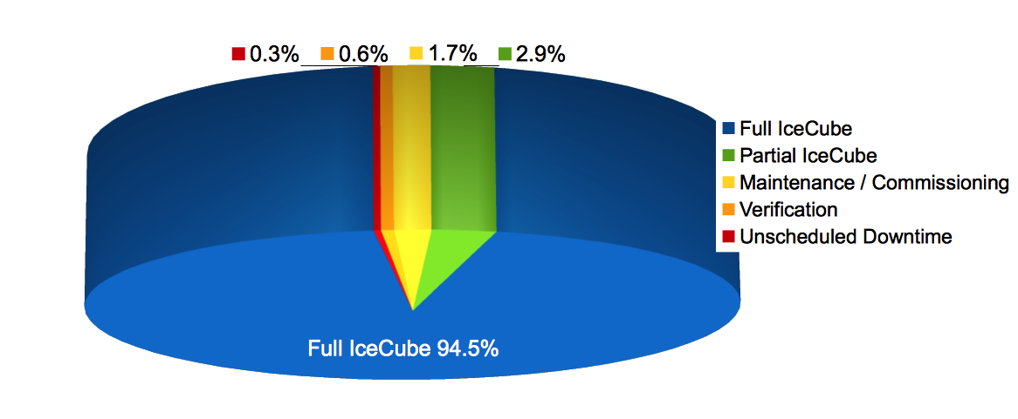

**Figure 1: Cumulative IceCube Detector Time Usage, 1 October 2011 – 1 September 2012**

An average detector uptime of 98.24% was achieved. This is higher than in prior years, as shown in Figure 2. The completion of IceCube construction during the previous austral summer and improved hardware and software stability are credited for improving uptime. Of the average uptime, 91.1% was clean uptime standard analysis.

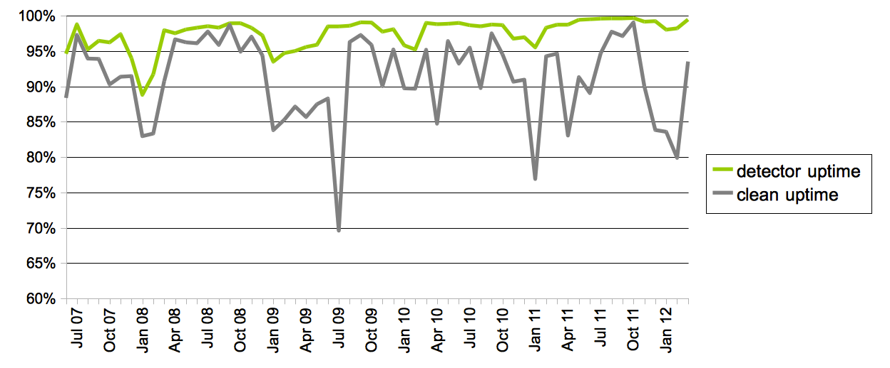

**Figure 2: Total IceCube Detector Uptime and Clean Uptime**

The good run list, during the period 1 October 2011 through 1 September 2012, found 96.8% of the data suitable for physics analysis. Figure 3 shows a concentration of bad runs during the austral summer and during preparations for the IC86-2 physics run from March to May. The remaining 3.2% primarily consisted of calibration runs using non-standard triggers and in-situ light sources such as the LED flashers whose data are not suitable for normal analysis. However, a portion of the detector is operated with full physics triggers during calibration runs and these data would be analyzed in the event of an extraordinary astrophysical transient event. An internal document that describes the good run list procedures has been posted at the following location:

<http://internal.icecube.wisc.edu/reports/data/icecube/2011/09/002/icecube_201109002_v1.pdf>.

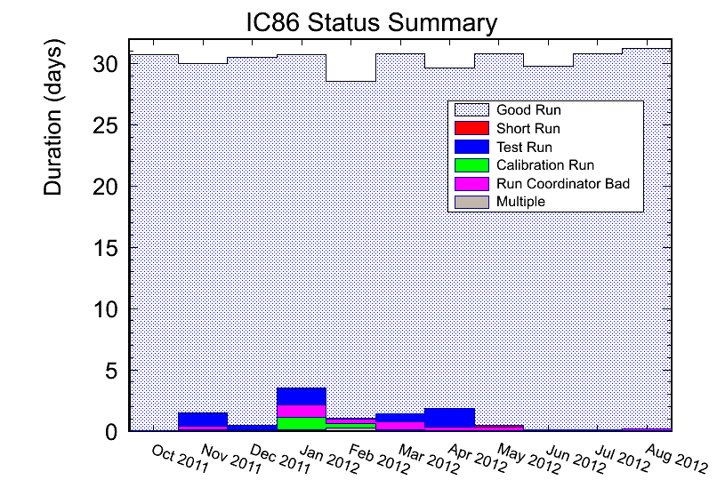

**Figure 3: Distribution of bad runs concentrate around austral summer activities and IC86-2 physics run preparation**

The IceCube Run Monitoring system, I3Moni, provides a comprehensive set of tools for assessing and reporting data quality. It collects and analyses raw subsystem data on the SPS immediately upon the completion of a run. The results are sent to the Northern Hemisphere via satellite, processed, and presented via a web-based user interface. IceCube collaborators participate in performing daily monitoring shift duties by reviewing information presented on the web pages and by evaluating and reporting the data quality for each run.

A new web interface to the monitoring system was developed and implemented. The monitoring web pages are integrated into IceCube Live (I3Live), an experiment control system and central portal for detector operations that allows operators in the Northern Hemisphere or at the South Pole to perform basic control operations on various subsystems and provides various views into the current and historical state of the detector. The original monitoring system was designed using a top-down approach – a set of processes run on a dedicated computer at SPS pulls data from the various subsystems – Processing and Filtering computer farm, DAQ stream of DOM monitoring records (temperature, high voltage, etc.), time calibration data stream, and supernova DAQ. In the current implementation, these data need to be processed, packaged together in the ROOT files for transfer to the Northern Hemisphere, and processed again in the north for displaying on the monitoring web pages. A recent increase of the messaging system data flow within I3Live v2.0 allows the development of a new push-based architecture in the backend of the monitoring system which will consolidate and simplify data gathering, storage, and displaying of the monitoring quantities.

In I3Moni 2.0, Processing and Filtering, pDAQ, supernova DAQ, Calibration, and Verification detector subsystems will report their data to I3Live via a ZeroMQ messaging system. The data will be stored in the I3Live database as soon as they become available. Newly designed monitoring web pages will summarize data in a tabular and graphical form, and provide tools for the shift-takers to detect problematic DOMs and/or runs, to compare data with the reference values, to perform automatic linear regression and other tests, to issue alerts, and to report any unusual detector behavior over a certain period of time. Major advantages of this new approach in the backend design include: simplicity and easier maintenance, flexibility, modularity, scalability, faster data presentation to the end user, and significant improvement in the overall longevity of the system implementation over the lifetime of the experiment. Using a database for data storage will also simplify long-term studies of the detector’s behavior, such as lifetime, historic variations in trigger and filter passing rates, PMT aging, etc.

During 2012, we have developed and documented in detail the I3Moni 2.0 system requirements, identified disposition of the monitoring quantities, designed standard tests to be run on the data, specified the data flow for an example of monitoring quantity, and developed an implementation schedule and plan. Prototyping of the upgrade of the monitoring system has already begun, and full implementation is planned for completion in 2013.

I3Live is currently running release v2.0, having been upgraded from v1.7 in June. The majority of changes in the last year support upgrades to I3Moni 2.0. The monitoring upgrades required improvements to the messaging system to handle the roughly 700x increase in the rate of data sent north through I3Live. This provides for the consolidation and simplification of run monitoring within the SPS subsystems where I3Live will manage the data collection and display of diagnostic and status information for the detector operators and IceCube collaborators.

A Supernova Light Curve display was added in v1.7 and provided a time profile of a detected signal in near real time. I3Live v2.1 is planned for the end of 2012 and will include features needed to eliminate run-cycle time between 8-hour runs as well as an automated failover safeguard that will reduce downtime in case of hardware failures. In addition to these feature upgrades, increased emphasis has been placed on the long-term maintainability of the system. For example, automated test coverage of the software has increased from 52% in December to a current level of 70%. A hardware upgrade of the Northern Hemisphere web site and test server is underway to replace seven-year-old machines. As part of this upgrade, a second, highly scalable NoSQL database will be added to support the long-term archiving of detector status data collected as a part of I3Moni 2.0.

The IceCube Data Acquisition system (DAQ) added new features and fixed issues in the Kirala, La Costeña, Ale Asylum, and upcoming Capital releases. Experimental support for buffering up to several hours of the complete pre-trigger data stream was added to the Kirala release. This feature was requested by the Supernova working group in order to extract a full record of all activity in the detector during future galactic core collapse events. Kirala was also upgraded to quickly cycle between physics runs to lessen the stop-start interval downtime between 8-hour runs, what amounted to a major component of the 0.1% detector downtime.

The La Costeña release was deployed for the start of the 2012 IC86 (IC86-2) physics run. A new FixedRate trigger was added to the trigger subsystem to capture large (10s of ms) windows of unbiased detector activity for detailed offline study of background. The SlowParticle trigger algorithm was updated to increase efficiency for very non-relativistic particles.

The computing host processor board, or SBC, in the IceCube DOMHub was identified as a bottleneck in DAQ processing. The CPU is 8 years old and running very close to its limit. Software features must be added with great care in order to assure that they do not overflow the computing budget. Several modern versions of the SBC were purchased from multiple vendors and tested in an effort to investigate upgrade strategies. The Advantech D525 and N455, and Axiomtex N450 SBCs were qualified as being compatible; however, performance issues persist even with these new platforms. A possible explanation is that the readout software has become optimally but narrowly tuned for the existing SBC and must undergo a new phase of performance tuning for any replacement board. We are also researching a more fundamentally revised system that may save power and rack space and provide additional readout channels for future extensions to IceCube.

A major source of downtime for DAQ is the run-cycle time between 8-hour runs, accounting for approximately three minutes per day. To eliminate these gaps in the data while still maintaining the necessary run-number switch every 8 hours, the DAQ is implementing a continual run feature that should be completed in the Capital release by the end of 2012. Changes were also necessary in IceCube Live, Processing and Filtering, and the database systems.

Hit spooling is a technique by which the DAQ saves the full raw data stream to a large disk buffer (10s of GB) resident on each readout computing host. The data can be retrieved up to hours later in the event of interesting triggers external to the DAQ, such as supernova alarms. In addition, data recorded but awaiting readout can still be accessed after DAQ crashes, thus increasing the likelihood of preserving vital data in the case of a very intense event that overloads the system. The hit spooling feature was added to DAQ in early 2012, and after several revisions of the design to improve stability and throughput, the system was tested successfully in summer 2012. Several tests involving long-term evaluation using runs spanning multiple days must be completed before the system is finally commissioned for normal operation.

Supernova DAQ found that 97.9% of the available data from 1 October 2011 through 6 September 2012 met the minimum analysis criteria for run duration and data quality. Trigger downtime was six days (1.8% of the time interval) and 16.4% of that downtime was from physics runs under 10 minutes in duration. Supernova candidates in these short runs can be recovered offline should the need arise.

A full redesign of supernova DAQ was installed on 18 January 2012 to improve the software maintainability and the data quality monitoring. The redesign follows a strictly object-oriented development paradigm combined with several defensive programming techniques, e.g., const-correctness. The trigger downtime due to short runs under 10 minutes was reduced by more than 60% and the overall data quality has been improved. The system monitors the total detector rate in 2 ms intervals and analyzes the data in 4 time bins optimized for the detection of the core collapse supernovae. In a second release in September 2012, several improvements were implemented. The handling of corrupted data was improved, installing and restarting the DAQ from scratch using a single fabric script was implemented, and the continuous monitoring of the DAQ performance was significantly improved, e.g., by recording the DAQ latency in short intervals. During the coming months, a total of 10 new monitoring quantities will be sent to IceCube Live; half of those will be transmitted every 10 minutes and the other half will be based on the statistics of a complete 8-hour run. All supplemental service scripts will be converted to a common scripting language, Python, to simplify maintenance.

Supernova DAQ and pDAQ are being extended to collect the time stamps of all DOM hits for a period around the time of highly significant triggers, and these data will be transmitted to the north via satellite. No information on the neutrino energy can be retrieved with the current system and the reach for supernova detection is therefore limited. By applying coincident criteria between adjacent DOMs, a measure of the neutrino energy can be extracted and the noise level can be reduced. Storing the timestamps of all hits on DOMhubs has been successfully tested on the SPS for a short duration. In the coming months, the test will be extended to run continually while fetching and transmitting data in case of external triggers, all without interfering with standard data taking. Supernova DAQ system monitoring will also be improved.

A supernova escalation scheme including a detailed flowchart of actions, in case of internal and/or external supernova triggers, was discussed and almost fully implemented. It provides clear responsibilities, defines procedures and technical means for immediate data quality checks, and lays out the path for quick announcement and publication. The immediate transmission of a neutrino light curve has been implemented in 500 ms bins via IceCube Live (Figure 4) and 2 ms bins via Iridium satellites, 30 s before through 60 s after a triggering event has been implemented. The 2 ms binned data is automatically analyzed in the north to determine key features of the signal. Furthermore, SMS messages are sent to a list of key recipients in case of a supernova alarm.

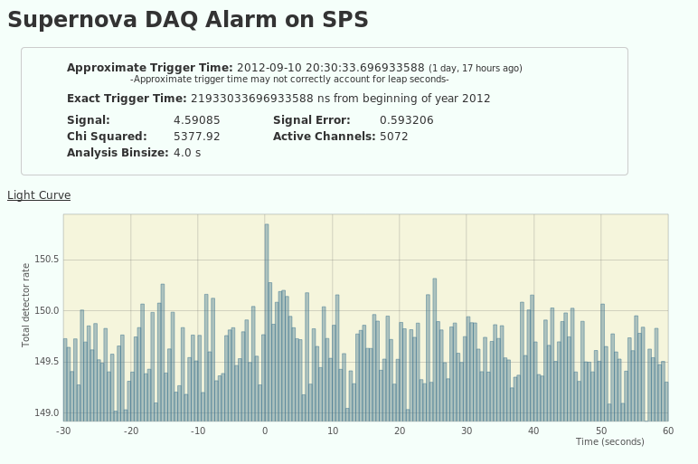

**Figure 4: Display of a Light Curve in IceCube Live from a trigger taken Sept. 10, 2012**

The online filtering system performs real-time reconstruction and selection of events collected by pDAQ. Version V12-05-00 was deployed ahead of the start of the IC86-2 physics run in May 2012. This release included a set of filters from the physics working groups, and improved, compressed data formats allowing for the transfer of a wider variety of physics data to the north. System development concentrated on final testing and deployment of a new version of the online filtering system and filters to support the new DAQ triggers that read out extended periods of data as a single event. These new long events are each composed of several standard DAQ events of interest to physics analyses. The updated software allows these events to be considered both as a long event and as many single events during filtering. Future development work will be aimed at revisions in support of I3Moni 2.0 with the direct reporting of quantities from the online filtering system to I3Live.

A weekly calibration call keeps collaborators abreast of issues in both in-ice and offline DOM calibration. A major new change in calibration is the refinement of the pedestal pattern calculation to eliminate occasional light contamination of the pedestal pattern and to avoid instability in the pedestals of recently rebooted DOMs. The updated code is part of domapp release 444 and was tested in August 2012. The test results are under study to confirm that the baselines are stable. Studies of DOM efficiency using in-ice muon data, flasher data, and data from the laboratory are ongoing in order to reduce the systematic uncertainty of DOM efficiency. The most recent study reduced the systematic uncertainty on DOM efficiency to 4.4%, previously 8%, for a given ice model. An effort is underway to refine the gain calibration using muon data which is collected continuously throughout the year. Muon monitoring software is being merged into the upcoming data monitoring V2.0 framework, with software tests planned for December 2012. A prototype of the I3Moni 2.0 software was successfully tested at a monitoring workshop in July 2012. Flasher data continues to be analyzed to reduce ice model systematics, with recent results including confirmation of ice tilt and evidence of scattering anisotropy in the ice.

The IceTop group rewrote many software components to adapt to the IceCube triggering system changes that incorporated the SLOP trigger into the core software chain and data format. A new filtering scheme was implemented for the online filtering. IceTop has been adapted to bring SuperDST charges for all events that trigger three or more IceTop stations. The waveforms are written only for events with five or more station triggers. The VEMCal project (calibration procedure for IceTop tanks) was also optimized to use SuperDST charges and less CPU processing at the South Pole. Data from several runs are averaged to obtain sufficient statistics to check charge fidelity. A new IceTop monitoring project was designed for detailed monitoring of waveforms and implemented within the verification project. We now monitor baselines, thresholds and charges extracted from all three channels of both ATWD chips per run.

A procedure for tracking IceTop snow depths between physical measurements was established last year and is working well. Snow depths will be physically measured at the South Pole during the coming season. The plan for snow management will be reviewed with South Pole station management for implementation in the coming season.

The two remote-controlled camera systems deployed at the bottom of the final string at 2450 meters were turned on for 15-20 minutes in January and September 2012. The observed hole structure of mainly clear ice with a white bubbly looking ice column in the middle remains unchanged. The camera systems will be turned on once every six months to observe any long-term changes.

***IC86 Physics Run –*** The second season of the 86 string physics run, IC86-2, began on 15 May 2012. Online improvements included the revised SlowParticle and new FixedRate triggers, the new SuperDST data compression format, and a simplified implementation for filters running on the SPS.

***TFT Board –*** The TFT board is in charge of adjudicating SPS resources according to scientific need. Working groups within IceCube submitted approximately 20 proposals requesting data processing, satellite bandwidth, and the use of various IceCube triggers for IC86-2. More sophisticated online filtering data selection techniques are used on the SPS to preserve bandwidth for other science objectives. New data compression algorithms (SuperDST) have allowed IceCube to send a larger fraction of the triggered events over TDRSS than in previous seasons. The additional data will enhance the science of IceCube in the study of cosmic ray anisotropy and the search for neutrino sources toward the galactic center.

The average TDRSS data transfer rate during IC86-1, which ran during the first half of this reporting period, was between 85 and 95 GB/day. The required bandwidth increased to an average rate of 95 to 105 GB/day during IC86-2, of which 5 GB/day is the Run Coordinator's reserve. The Run Coordinator's reserve was decreased to keep within the requested bandwidth of the 2012/13 SIP. IceCube is a heavy user of the available bandwidth and we will continue to moderate our usage without compromising the physics data.

The TFT Board assumed responsibility for the offline level 2 processing in May, 2012. Level 2 processing adds reconstructions and other CPU-intensive calculations that are useful to the wider collaboration. Level 2 processing is done in the Northern Hemisphere with the South Pole filtered data as input.

***Computing and Data Management***

***Computing Infrastructure –*** IceCube computing infrastructure and storage systems both at the Pole and in the north have performed well over the past year. Significant upgrades to the data warehouse were completed in 2012, including 300 TB of new data storage for experimental data, 400 TB for simulation, and 75 TB for data analysis. This brings total storage capacity to 1.1 PB for experimental data, 1.4 PB for simulation, and 135 TB for analysis. Another 300 TB of disk storage will be added in 2013 to accommodate incoming experimental data and 100 TB will be added for data analysis activities.

Data processing systems at UW***–***Madison were upgraded to add capacity and retire old hardware. A 512-core extension was added in early 2012 and 768 cores will be added by November 2012. The oldest 512 cores will be retired as the newest cores are integrated.

A Graphics Processing Unit (GPU)-based cluster, named GZK-9000, was installed to support the direct photon propagation methods used by the newest generation of simulation software. This cluster comprises 48 GPUs and 288 CPUs and delivers 48 TeraFLOPS peak performance. An expansion of approximately 60 GPUs is planned for 2013 to enable the production of one year of detector live-time simulation in a timely manner.

The South Pole System data movement servers and supporting storage systems were upgraded during the 2011/12 austral summer. The lifecycle replacement of the ERM battery packs in all racks was completed. Many smaller subsystems were reorganized and consolidated to improve reliability, preserve power consumption, and conserve rack space.

A complete upgrade of the SPS network is planned for the 2012/13 austral summer. The existing Cisco switches will be replaced with Cisco 3750-X switches. In addition, a second set of switches will be added to enable the dual connection of all hosts and DOMHubs providing redundant network paths to all detector systems. This will minimize the impact of network switch failures on detector uptime. In addition, a second UPS will be added to each rack to provide greater redundancy in power distribution to detector systems.

The annual test of the fire suppression system in the IceCube Lab (ICL) will take place in late November. IceCube personnel will be present in the ICL during this test to ensure that any outages or side effects of the test are caught and immediately remedied as per our agreement with the Antarctic Support Contractor.

***Data Movement –*** Data movement has performed nominally over the past five months. Figure 5 shows the daily satellite transfer rates in MB/day through August 2012. The IC86 filtered physics data, in cyan, dominates the total bandwidth. The decline in May was due to a transmitter problem at the Pole. In June, the transmitter problem was fixed and the backlog was cleared. Data movement returned to a steady rate of transfer for July and half of August.

In the second half August, a problem with a Ku-band waveguide at the Pole prevented all science data transfers. After replacement of the defective waveguide, science data transfers have resumed. The current transfer rate is currently higher than the nominal rate in order to clear the backlog. It is expected that the backlog will be clear and the transfer rate will return to the nominal rate in October.

The IceCube data are archived on two sets of duplicate LTO4 data tapes. Data movement goals were met despite some outages for maintenance. A total of 273 TB of data were written to LTO tapes, averaging 804 GB/day. A total of 28 TB of data were sent over TDRSS, averaging 82 GB/day.

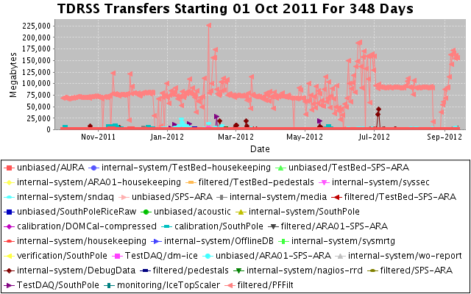

**Figure 5: TDRSS Daily Data Transfer Rates**

***Offline Data Filtering –*** The offline filtering of IC86-1, May 2011 through April 2012, is complete. Final checks and validation of the filtered data will be completed this month. The Collaboration has agreed to add Deutsches Elektronen-Synchrotron, DESY, as a redundant offline data storage center, which will improve data accessibility. UW***–***Madison and DESY have established the requirements and framework for automated transmission of offline data between their data centers. The IC86-1 data storage requirement of 101 TB was within the initial 105 TB estimate. Copying the IC86-1 data from UW***–***Madison to DESY has commenced.

Offline processing of IC86-2 data, May 2012 through April 2013, will begin this fall and should catch up to near real time by the end of 2012. When offline filtering is processing the current data from the South Pole, the goal of bringing offline processing as close as possible to the start of data collection will have been accomplished.

***Simulation –*** Production of IC79 Monte Carlo began in September 2011 and is complete with the exception of a few datasets needed for studies of systematic uncertainties. Producing simulations of direct photon propagation using Graphics Processing Units, or GPUs, began with a dedicated pool of computers built for this purpose in addition to the standard CPU-based production. IC86-1 production recently started. We have progressed toward having 100% of all simulations based on direct photon propagation using GPUs or a hybrid of GPU and spline-photonics for high-energy events. The production sites are: CHTC – UW Campus (including GZK GPU cluster); Dortmund; DESY-Zeuthen; EGEE – German Grid; SWEGRID – Swedish Grid; PSU – Pennsylvania State University; LONI – Louisiana Optical Network Infrastructure; GLOW – Grid Laboratory of Wisconsin; UMD – University of Maryland; IIHE – Brussels; Ruhr-Uni - Bochum; UC Irvine; and NPX3 – UW IceCube.

***Personnel –*** A software professional was added at 1.0 FTE in shared support of DAQ and IceCube Live. A 0.5 FTE system administrator’s time was increased to 1.0 FTE in the area of data management and disaster recovery. A 1.0 FTE system administrator position responsible for virtualization was filled. A 1.0 FTE software professional in the areas of data analysis and detector simulation was filled. The computing and data manager position held by Martin Merck was vacated and an international job search is underway. Steve Barnet is serving as the acting manager.

***Data Release***

***Data Use Policy***

IceCube is committed to the goal of releasing data to the scientific community. The following links contain data sets produced by AMANDA/IceCube researchers along with a basic description. Due to challenging demands on event reconstruction, background rejection and systematic effects, data will be released after the main analyses are completed and results are published by the international IceCube Collaboration. The following two links give more information about IceCube data formats and policies.

IceCube Open Data: <http://icecube.umd.edu/PublicData/I3OpenDataFormat.html>

IceCube Policy on Data Sharing:

<http://icecube.umd.edu/PublicData/policy/IceCubeDataPolicy.pdf>

***Datasets (last release on 5 Sep 2011): http://icecube.wisc.edu/science/data***

The pages below contain information about the data that were collected and links to the data files.

AMANDA 7 Year Data: <http://icecube.wisc.edu/science/data/amanda>

IceCube String 22 - Solar WIMP Data: <http://icecube.wisc.edu/science/data/ic22-solar-wimp>

IceCube String 40 Data: <http://icecube.wisc.edu/science/data/ic40>

***Program Management***

***Management & Administration*** –The primary management and administration effort is to ensure that tasks are properly defined and assigned and that the resources needed to perform each task are available when needed. Efforts include monitoring that resources are used efficiently to accomplish the task requirements and achieve IceCube’s scientific objectives.

* The FY2012 M&O Mid-Year Report was submitted in April 2012.
* The detailed M&O Memorandum of Understanding (MoU) addressing responsibilities of each collaborating institution is currently being revised for the collaboration meeting in Aachen, Germany, October 1-5, 2012.
* Computing resources are managed to maximize uptime of all computing services and to ensure the availability of required distributed services, including storage, processing, database, grid, networking, interactive user access, user support, and quota management.
* NSF provided funding of $6,900,000 to UW-Madison to support M&O activities in FY2012. This support includes a total contribution of $941,850 to the U.S. Common Fund. Subawards with six U.S. institutions were issued through the established University of Wisconsin-Madison requisition process (financial details in Section III).
* NSF provided an additional $193,749 in funding to be used in FY2013 to support an approved IceCube M&O proposal supplement for cyberinfrastructure. The funding provides for the software development required to modify the IceCube data acquisition, processing, and transmission software to create data pipelines making near real time neutrino events available to other facilities.

### 

### *IceCube M&O - FY2012 Milestones Status*

|  |  |  |
| --- | --- | --- |
| **Milestone** | **Planned** | **Actual** |
| Provide NSF and IOFG with the most recent Memorandum of Understanding (MoU) with all U.S. and foreign institutions in the collaboration. | Sept. 2011 | Sept. 16, 2011  MoU v11.0 |
| Annual South Pole System hardware and software upgrade. | Jan. 2012 | Jan. 2012 |
| Revise the institutional Memorandum of Understanding Statement of Work and PhD Authors Head Count for the spring collaboration meeting. | Mar. 2012 | Mar. 15, 2012  MoU v12.0 |
| Submit a mid-year report with a summary of the status and performance of overall M&O activities, including data handling and detector systems. | Mar. 2012 | Apr. 10, 2012 |
| Report on scientific results at the spring collaboration meeting. | Mar. 2012 | Mar. 2012 |
| Provide NSF and IOFG with the most recent Memorandum of Understanding (MoU) with all U.S. and foreign institutions in the collaboration. | Apr. 2012 | May 3, 2012  MoU v12.0 |
| Annual NSF IceCube M&O Review (reverse site visit to NSF) | May 2012 | May 24, 2012 |
| Submit to NSF an annual report which describes progress made and work accomplished based on M&O objectives and milestones. | Sept. 2012 | Sept. 13, 2012 |
| Revise the institutional Memorandum of Understanding Statement of Work and PhD Authors Head Count for the fall collaboration meeting. | Sept. 2012 |  |
| Report on scientific results at the fall collaboration meeting. | Oct. 2012 |  |
| Annual detector up-time self assessment. | Oct. 2012 |  |

***Engineering, Science & Technical Support*** –Ongoing support for the IceCube detector continues with the maintenance and operation of the South Pole Systems, the South Pole Test System and the Cable Test System. The latter two systems are located at the University of Wisconsin–Madison and enable the development of new detector functionality as well as investigations into various operational issues such as communication disruptions and electromagnetic interference. Technical support provides for coordination, communication, and assessment of impacts of activities carried out by external groups engaged in experiments or potential experiments at the South Pole. The IceCube detector performance continues to improve as we restore individual DOMs to the array at a faster rate than problem DOMs are removed during normal operations.

***Software Coordination –*** A review panel for permanent code was assembled for the IceTray-based software projects and to address the long-term operational implications of recommendations from the Internal Detector Subsystem Reviews of the online software systems. The permanent code reviewers are working to unify the coding standards and apply these standards in a thorough and timely manner. The internal reviews of the online systems mark an important transition from a development mode into steady-state maintenance and operations. The reviews highlight the many areas of success as well as identify areas in need of additional coordination and improvement.

Work continues on the core analysis and simulation software to rewrite certain legacy projects and improve documentation and unit test coverage. The event handling in IceTray is being modified to solve two related problems: 1) the increasing complexity of the triggered events due to the size of the detector and the sophistication of the online triggers, and 2) the increasing event size due to different optimizations of the hit selections used in different analyses.

***Education & Outreach (E&O)*** –IceCube collaborators continue to engage national and international audiences in a multitude of venues and activities. We provide noteworthy examples below followed by exciting aspects of the growing IceCube E&O program made possible with the development of new activities and partnerships.

**Public engagement:**

To celebrate the 100th anniversary of South Pole exploration, IceCube hosted an evening of exploration and learning at the Wisconsin Institutes for Discovery on the campus of the University of Wisconsin–Madison. The event, titled “100 Years of Discovery: From the South Pole to the Edge of the Universe” showcased the history of Antarctic exploration and science. Presenters included individuals from around campus. The event attracted over 200 visitors who learned about Antarctica’s volcanic rocks, neutrino astronomy, wildlife, meteorology, and ice sheets.

At South Pole centennial events, IceCube staff interacted with the Norwegian Prime Minister and engaged tourists at the NSF Visitor Center. During an open house, staff answered questions about the detector and discussed research with visitors. IceCube winterover Sven Lidstrom later provided a presentation specifically on the IceCube Neutrino Observatory.

In February 2012, collaborator Spencer Klein presented at a multi-disciplinary “Science in the Theater” event in Berkeley, California. His segment included a phone call with IceCube winterovers and a question-and-answer session. The crowd of nearly 500 people was mostly general public, with a large number of high school students attending.

In Belgium, University of Gent researchers participated in a local “Children’s University,” interacting with approximately 300 children aged 9 to 12. Following a talk on Antarctica and the IceCube Neutrino Observatory, they conducted an ice drilling workshop where students drilled into 50 cm ice blocks.

At the Vrije Universiteit Brussel in Brussels, Belgium, IceCube collaborators provided a workshop at the university-organized “Autumn Camp in Sciences.” Researchers also set up cosmic ray detectors in a few local schools and gave talks at local astronomical societies, the Royal Academy, and other locations.

IceCube had a significant presence at the National Science Teachers Association annual meeting, helping staff a booth hosted by the NSF Office of Polar Programs and conducting a workshop.

**Other education and outreach activities included:**

* Science Saturday at the Wisconsin Institutes for Discovery. The theme was Antarctica, and the event included representatives from Antarctic weather stations and biological research. The morning event was aimed at families and included a bilingual component, with presentations on IceCube and meteorology in English and Spanish.
* The Lawrence Berkeley National Laboratory annual open house. With a combination of hardware, models, and an electronic display, the IceCube team engaged over 400 visitors.
* Presentation of “Ice fishing for neutrinos” by Dr. Francis Halzen in Pittsburg, PA in conjunction with the Wisconsin Alumni Association’s Founders’ Day events
* Spring Science Soiree with the Madison Children’s Museum. This event is an “Adult Swim” attracting over 500 adults to the museum for after-hours presentations and activities by local researchers. Cloud chamber setups attracted many curious visitors, which led to many in-depth conversations with researchers.
* IceCube participated in UW–Madison days at the Wisconsin State Fair in Milwaukee, Wisconsin. IceCube volunteers included graduate students, researchers, engineering staff, and computer scientists, many of whom were attending their first outreach event.
* Regular small-scale presentations and interviews at schools, rotary clubs, civic groups, alumni associations, and planetarium societies around the U.S. and Europe.

**New Activities:**

IceCube collaborators continue to explore new ways to interact with learners. For example, “Seeing the Universe Through Different Eyes” uses galactic images and filters to help kids understand that there are different ways to look at the Universe, creating a frame of reference for them to understand the function of a neutrino detector vs. an optical telescope. A new LED programming activity allows learners to use basic programming commands to control the color, duration, and intensity of red, green, and blue LED modules. The activity introduces the concept of computer control of real devices, explains how LEDs work, and how they are used in the IceCube detector.

UW-Madison researchers recently participated in a “Cosmic Ray Café” for the first time at a weekly public science venue on campus. The session began with a 30-minute lecture on cosmic rays and was followed by intimate conversations in small groups. Researchers and graduate students staffed tables and discussed particle physics, working in Antarctica, and historic discoveries that paved the way for IceCube. This setting enhanced the learning experience for both researchers and participants and was broadcast by Wisconsin Public Television.

IceCube is focusing on developing an approach to public engagement that utilizes a narrative arc to introduce the complex and exotic topics of astroparticle physics. The narrative arc builds from familiar, concrete examples like mapping or viewing surroundings in multiple ways and on different length scales. Incremental steps introduce increasing levels of complexity and abstraction to show how the same basic ideas are present in more unfamiliar topics like neutrino astronomy. This approach, which utilizes hands-on activities, helps audiences grasp science concepts more effectively than from lectures alone, resulting in greater comfort and competence with abstract science topics.

**Future projects and partnerships:**

IceCube E&O staff continue to build partnerships that will help bring neutrino science to new audiences and engage people in new ways.

Developing new partnerships with the Milwaukee Public Museum and Minnesota Planetarium Society has allowed IceCube to tap into anther medium for science E&O, the digital dome. The University of Wisconsin at River Falls has upgraded their planetarium with a digital projector, allowing the system to move beyond standard viewing of the night sky to enable better visualization of scientific data. Plans to expand the network across the state of Wisconsin will allow IceCube to efficiently present scientific data to colleagues and the general public.

The Milwaukee Public Museum is working with IceCube E&O personnel to create a high-quality planetarium show showcasing IceCube science. The project has the potential to impact hundreds of thousands of people given the extensive planetarium network and has an anticipated completion of September 2013.

The Wisconsin IceCube Particle Astrophysics Center (WIPAC) recently received an outreach grant from the Ira and Ineva Reilly Baldwin Wisconsin Idea Endowment. The project, called “Bringing the Universe to Wisconsin,” will share WIPAC research with Wisconsin residents. Over the next two years WIPAC personnel will visit and present at each two- and four-year University of Wisconsin system campus and community. This partnership allows communities access to researchers, engineers, and computer technicians that have worked on major neutrino astronomy projects, including information about IceCube, the Askaryan Radio Array (ARA), and DM-Ice. Showcasing the Wisconsin connections that have made this project possible, along with funding from the NSF, has the potential to excite and attract thousand of attendees to these events over the next two years.

**Student experiences:**

IceCube is dedicated to providing research experiences for undergraduates, K-12 teachers, and two- and four-year university faculty. IceCube scientists at UW–Madison sponsor two REU students and fund 10 to 15 undergraduate students at any time during the summer; additionally, several IceCube collaboration institutions provide similar research opportunities for undergraduates. Students collaborate on a variety of IceCube research projects, including data analysis, information technology, communications, and outreach. Madison also hosts high school summer interns from the Information Technology Academy, a four-year program for minority youth.

NSF’s PolarTREC program is enabling IceCube to send high school teacher and Knowles Science Teaching Foundation fellow Liz Ratliff to the South Pole for the 2012-2013 summer season. In addition to interacting with her students, Ratliff has the potential to reach thousands of students and hundreds of teachers through her blog posts and webcasts.

**Section III – Project Governance and Upcoming Events**

The detailed M&O institutional responsibilities and Ph.D. author head count is revised twice a year at the time of the IceCube collaboration meetings. This is formally approved as part of the institutional Memorandum of Understanding (MoU) documentation. The MoU was last revised in March 2012 for the Spring collaboration meeting in Berkeley, CA (v 12.0), and the next revision (v13.0) will be posted in October 2012 at the fall collaboration meeting in Aachen, Germany.

***IceCube Collaborating Institutions***

In September 2011, at the 2011 fall collaboration meeting in Uppsala, three new institutions joined the IceCube Collaboration:

* Université de Genève (DPNC), institutional lead is Dr. Teresa Montaruli
* Stony Brook University (SBU), institutional lead is Dr. Joanna Kiryluk
* University of Adelaide, institutional lead is Dr. Gary Hill

In February 2012, Technische Universität München (TUM) joined the IceCube Collaboration and Max Planck Institute (MPI) at Heidelberg left IceCube, after the institutional lead Dr. Elisa Resconi officially moved from MPI to TUM.

In June 2012, the University of the West Indies in Barbados left the IceCube Collaboration after the institutional lead Dr. Surujhdeo Seunarine moved to the University of Wisconsin–River Falls.

The list of current IceCube collaborating institutions can be found on:

http://icecube.wisc.edu/collaboration/collaborators

***IceCube Major Meetings and Events***

IceCube Spring Collaboration Meeting – University of California, BerkeleyMarch 19-23, 2012

NSF M&O Reverse Site Visit May 24, 2012

IceCube Fall Collaboration Meeting - Aachen, Germany October 1-5, 2012

# Acronym List

ARA Askaryan Radio Array

CF Common Fund

DAQ Data Acquisition System

DOM Digital Optical Module

IceCube Live The system that integrates control of all of the detector’s critical subsystems

IceTray IceCube core analysis software framework is part of the IceCube core software library

ICL IceCube Laboratory (South Pole)

LED Light-emitting Diode

MoU Memorandum of Understanding between UW-Madison and all collaborating institutions

REU Research Experience for Undergraduates

SIP Support Information Package

SPS South Pole System

TDRSS The Tracking and Data Relay Satellite System is a network of communications satellites

TFT Board Trigger Filter and Transmit Board

WIPAC Wisconsin IceCube Particle Astrophysics Center

1. *Based on IceCube Institutional Memorandum of Understanding v10.0*