CosRay – Neutron Monitors at the South Pole
Submitted by Paul Evenson, University of Delaware
In contrast to the investigations that seek to extend the range of IceCube to higher energy CosRay works with IceTop to extend the energy range to lower energy (1-10 GeV) primarily to study the acceleration and transport of solar energetic particles. Most of the processes invoked in acceleration models for high energy astrophysical particles also occur on the sun but at different scales. Even though the sun is much closer, and many independent acceleration episodes have been observed, there is still much that is not understood about both acceleration and transport of the energetic particles. Although it works closely with IceTop, CosRay is funded separately by NSF as Event A-118-S.
CosRay at Pole had its origins in 1964 as a neutron monitor installed by Martin Pomerantz, and is still often referred to simply as “the neutron monitor”. Actually “neutron monitor” is an unfortunate term since it seems to imply something rather static and boring. Only “right whale” and “edible dormouse” come quickly to mind as examples of more unfortunate names. A neutron monitor is a detector type, not an investigation. One could also refer to IceCube as “new photomultiplier array installed at Pole”. In fact, CosRay has been reinvented and reinvigorated several times over the years.
The overall objectives of CosRay may be summarized as:
- Detect energetic (~1-10 GeV ) particles that propagate through the interplanetary magnetic field
- Characterize time variations, energy spectra, and composition of particles accelerated on the Sun in order to
  - Understand the interplanetary magnetic field
  - Figure out what is happening on the Sun and when it happens
- Relate all of the above to astrophysical acceleration and propagation
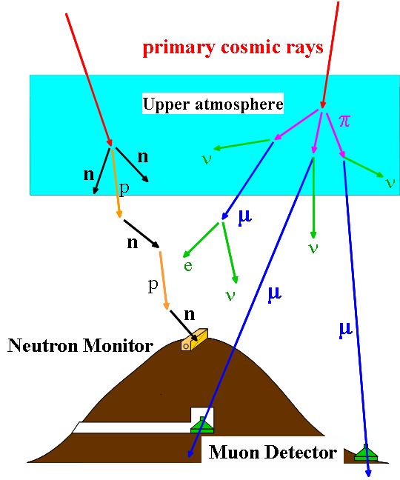
For brevity we omit a detailed discussion of the solar and heliospheric processes that are the basis of acceleration and transport models although we touch on some of these points in the following discussion.
Figure 1.
A neutron monitor is actually an air shower experiment (Figure 1) like IceTop, with one key difference – the air showers are originated by “low energy”, typically 1-10 GeV particles that produce, again typically, only one secondary at ground level (or in the case of Pole at the surface of the ice). Ground-based detectors in general measure byproducts of the interaction of primary cosmic rays (predominantly protons and helium nuclei) with Earth’s atmosphere. There are two common types in general use today. Neutron monitors respond to primary energies of ~1 GeV for solar cosmic rays and ~10 GeV for Galactic cosmic rays. Muon detectors respond to primaries with a typical energy of ~50 GeV for Galactic cosmic rays for a detector near the surface. Particles accelerated on the sun rarely reach this energy.
Spacecraft instruments are elegant examples of design that return fantastically detailed information on particle intensity and spectrum. Unfortunately they are almost invariably small and even in principle cannot detect enough particles at 1 GeV and above to be useful for transient events (e.g. solar flares). Although ground based detectors are crude by comparison, they can be made big, and offer excellent timing and yield statistically extracted spectra
Neutron monitors are most valuable when they are operated as a network, since energetic particles (guided by the interplanetary magnetic field) often arrive with high anisotropy. The network most closely relevant to Pole is Spaceship Earth, (Figure 2) an international collaboration organized by the University of Delaware Bartol Reseach Institute. Spaceship Earth is a network of twelve neutron monitors on four continents deployed to provide precise, real-time, three-dimensional measurements of the angular distribution of solar cosmic rays.
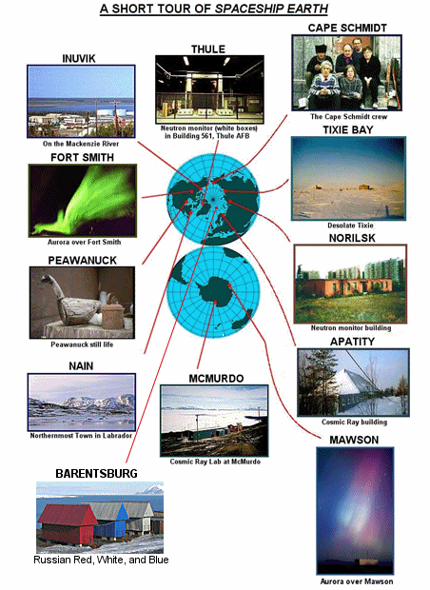
The multi-national participants in Spaceship Earth are:

Bartol Research Institute, University of Delaware (U.S.A.)
IZMIRAN (Russia)
Polar Geophysical Inst. (Russia)
Inst. Solar-Terrestrial Physics (Russia)
Inst. Cosmophysical Research and Aeronomy (Russia)
Inst. Cosmophysical Research and Radio Wave Propagation (Russia)
Australian Antarctic Division
Aurora College (Canada)

Figure 2.

Each neutron monitor has a “viewing” or asymptotic direction from which particles striking the atmosphere above the detector come. This direction, which is a function of particle energy, is determined by the geomagnetic field. It can be accurately calculated from time dependent models of the geomagnetic field. The viewing directions (Figure 3) are typically indicated as points on the surface of the Earth, but the interpretation of these points is that the arrival direction, several earth radii removed from the surface, is parallel to the radius from the center of the earth to the point on the surface. Spaceship Earth viewing directions are optimized for solar cosmic rays. Nine stations view equatorial plane at 40-degree intervals, while Thule, McMurdo, and Barentsburg provide crucial three dimensional perspective. In the figure, solid symbols denote station geographical locations. Average viewing directions (open squares) and range (lines) are separated from station geographical locations because particles are deflected by Earth's magnetic field. The ends of the lines correspond to the 10th and 90th percentile for a typical solar particle spectrum. The end closest to the station is the high energy end, since in this representation particles of infinite energy would arrive directly overhead.
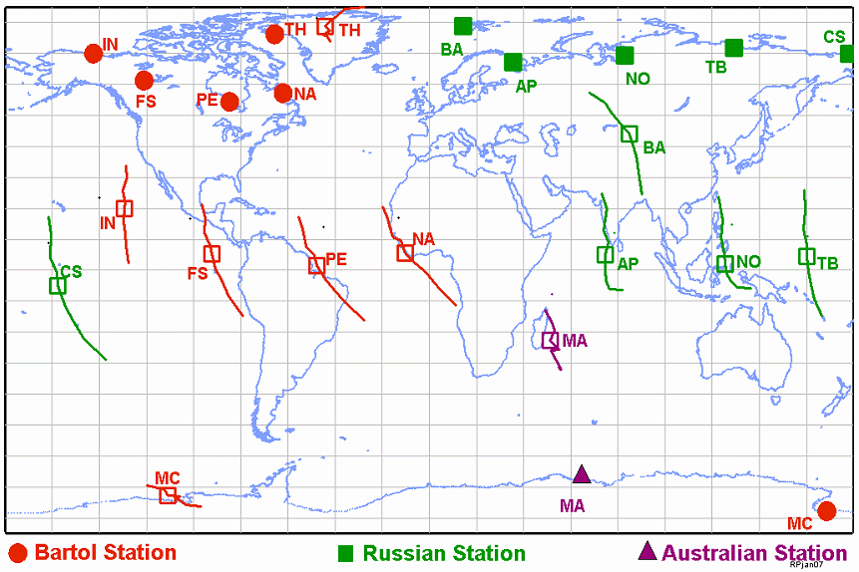
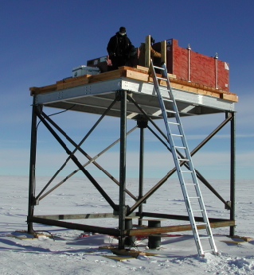
Pole complements Spaceship Earth. Its viewing direction is equatorial, often quite close to that of Nain. However the high altitude and very low geomagnetic cutoff of Pole result in secondary particle spectra that still contain a lot of information about the spectrum of the primary particles. By using combinations of properly “tuned” detectors the data can be deconvoluted to estimate the incoming spectrum.
STATION CODES
IN: Inuvik, Canada
FS: Fort Smith, Canada
PE: Peawanuck, Canada
NA: Nain, Canada
BA: Barentsburg, Norway
MA: Mawson, Antarctica
AP: Apatity, Russia
NO: Norilsk, Russia
TB: Tixie Bay, Russia
CS: Cape Schmidt, Russia
TH: Thule, Greenland
MC: McMurdo, Antarctica
Figure 3.
Figure 4.
There are two types of neutron monitor operating at Pole (Figure 4). Both use ³He filled proportional counters that detect neutrons via the fission reaction n + 3He → p + 3H. The installation on the platform between the station and the clean air facility is a standard 3NM-64 in which the proportional counters are embedded in layers of lead and polyethylene. The peak response is to 100 MeV hadrons (mostly neutrons but also many protons) that interact with ²⁰⁸Pb to produce multiple low energy “evaporation” neutrons which “thermalize” in the polyethylene and are ultimately detected by the proportional counters. The “3” refers to the three separate detectors on the platform. On the mezzanine in B2-Science is an array of twelve unleaded detectors, two of which are in paraffin moderators. These “Polar Bares” responds to slightly lower particle energy on average. The moderators make little difference in the response energy, but these detectors were specifically calibrated via a latitude survey aboard the icebreaker Oden. (A “latitude survey” exploits the variation of geomagnetic cutoff with position on the earth to vary the input spectrum at the top of the atmosphere in a calculable way. The derivative of the counting rate of the detector with respect to geomagnetic cutoff is the quantity referred to later as the “response function” of the detector.
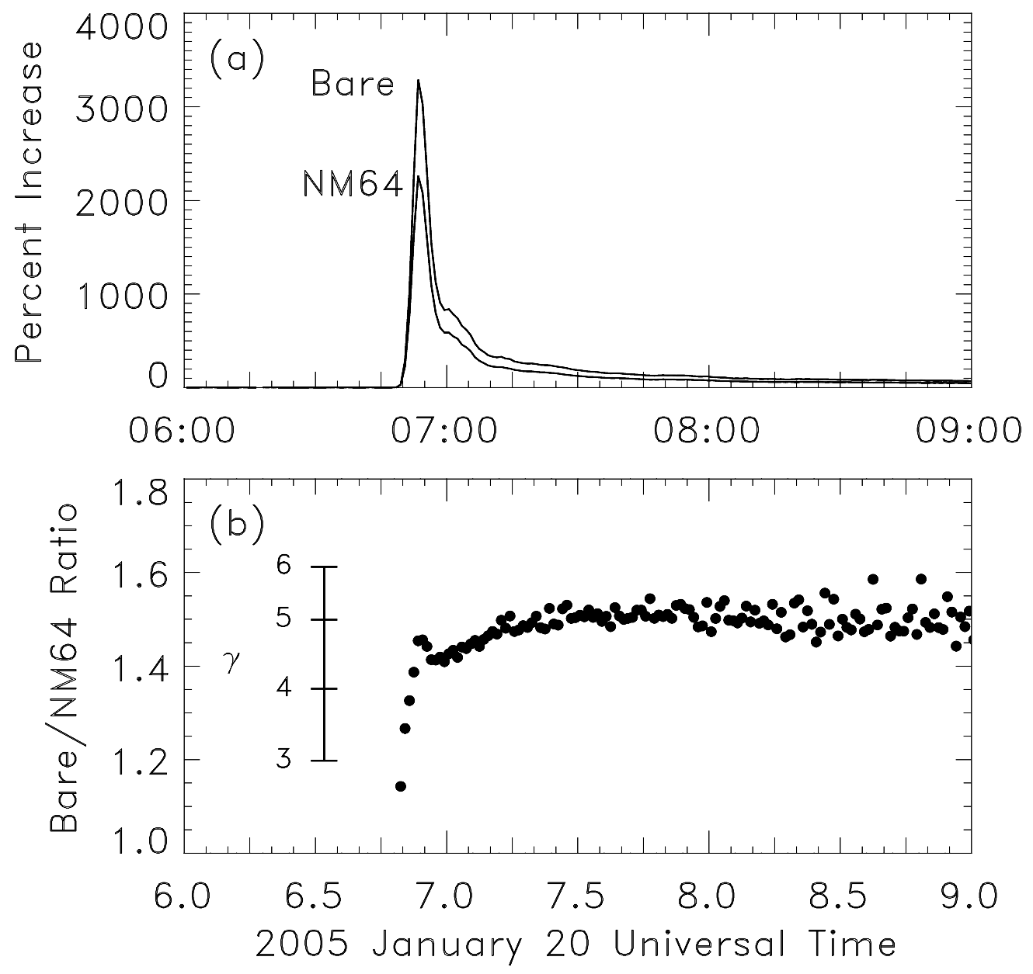
Since the Polar Bares and NM64 have different response functions the ratio of their counting rates provides information on the incident particle spectrum. Figure 5 shows the increase in counting rate in response to a large solar flare in the top panel. The lower panel shows the ratio of the increases along with a scale that indicated the spectral index under the assumption that the spectrum is composed purely of protons and is a power law in momentum. Since we measure only two numbers we can extract only two parameters, one of which is the overall intensity.
Figure 5.
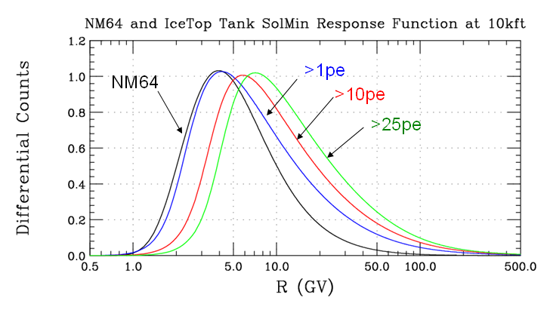
The Cherenkov “tank” detectors of IceTop on the other hand are analog devices, returning the distribution of light signals, as opposed to a simple counting rate. In a neutron monitor the signal results from the fission reaction and all counts are identical, independent of the energy or species of the primary. In contrast the signal spectrum of IceTop carries a lot of information on the incident particles. One tank therefore has a whole series of response functions, each corresponding to a particular signal threshold, and they all can be measured simultaneously.
Figure 6.
Figure 6 illustrates calculated response functions for IceTop for thresholds of 1, 10, and 25 photoelectrons as well as a response function for an NM64. (An IceTop tank was also included in the recent latitude survey on Oden to calibrate the response functions.).
The multiple response functions of the tank allow for the extraction of a more precisely determined spectrum than can be obtained from the monitors. To date we have derived a spectrum for one solar particle event, that of 13 December 2005. In the figure we use this spectrum and the response function of a neutron monitor to calculate the response of a neutron monitor, shown by the heavy points. The Pole monitor was not operating at that time so we cannot make a direct comparison. Instead we show data from a number of neutron monitors. Our calculation is very consistent with the data from monitors looking in the same direction. This event was initially very isotropic, with a tight beam of particles coming along the magnetic field line from the sunward direction. The monitors looking in this direction see intense fluxes early in the event. As the beam is very narrow there are significant variations in amplitude due to fluctuations in magnetic field direction. Monitors (and IceTop) looking away from the sun only see particles several minutes later as they are reflected back by irregularities in the interplanetary magnetic field.
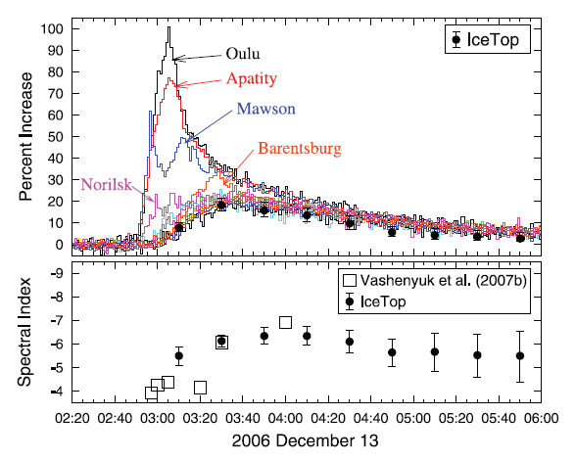
In Figure 7 we also compare the spectral index derived from IceTop with a more conventional spectral determination using neutron monitors at differing geomagnetic cutoffs. In this method, spectrum and anisotropy are jointly extracted, usually under the assumption that the spectrum is independent of direction. The divergent results early in the event indicate that this is not a good approximation although late in the event, when particles arrive nearly isotropically, agreement is good. The overall lesson here is, however, that IceTop and/or the Pole monitors cannot live in isolation. A precise spectrum from one direction must still be interpreted in its overall context and that requires a network of detectors.
Figure 7.
Although the NM64 response function peaks at an energy similar energy to that of the lowest energy IceTop response function it has a crucial difference in shape that enables determination of the composition of the particles which has never been measured at GeV energies. Since composition is extremely variable at lower energies, and different particle species often have significantly different energy spectra, simple extrapolation is essentially meaningless.
Unknown composition is a source of error in measuring the spectral index with neutron monitors alone. The figure shows simulated loci of count rate ratios, jointly varying spectral index (horizontal) and helium fraction (vertical). The simulation is based on the spectral index and intensity of the large solar flare of 20 January 2005, and the assumption of “galactic” composition. Statistical errors (+/- one sigma) are represented by the line thickness. Any point on the red curve is equally allowed – in other words the measured spectral index can range from 4.0 to 4.5 depending on the actual composition.
The situation with IceTop is somewhat better because several (in fact multiple) ratios can be formed using the set of response functions. Figure 8 shows count rate ratios for the indicated thresholds (expressed in terms of signal amplitude measured in detected photoelectrons. Over some of the parameter space, consideration of IceTop signals alone and requiring agreement of the spectral index and composition measured by all of the separate thresholds concurrently could resolve the ambiguity. However the various curves all tend to converge in what is probably the most likely region of parameter space – a helium abundance of 10% or less.
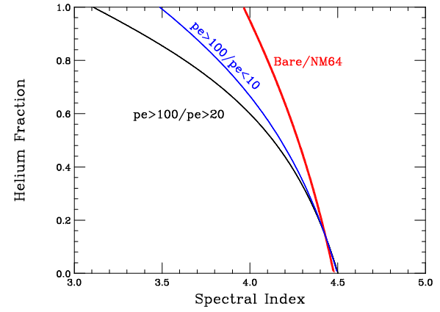
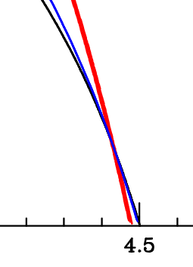
This is not the case when the neutron monitor and IceTop are taken together. The lines have a well defined intersection at the correct (i.e. simulation input) values of spectrum and helium fraction.
Figure 8.
The combination of IceTop and CosRay is poised to contribute to understanding several issues important to heliospheric physics during the approaching solar maximum. Because of space limitations we simply list them, along with the investigations expected to provide complementary data.

- Details of the particle energy spectrum, such as the double power law in rigidity reported by Tylka and co-workers.
  - High resolution spectra1-10 GV (IceTop, PAMELA)
  - Search for an upper cutoff (HAWC, Auger)
- Are high energy particles enhanced in heavy nuclei as conjectured by Lopate and co-workers.
  - Composition at high energy (IceTop/NM/Bare)
- Is there a qualitative difference between flares that do and do not produce GeV particles
  - Small event search (IceTop)
- What is the temporal structure of solar acceleration? Are there multiple acceleration events as claimed by several authors?
  - Better angular and temporal separation (NM network augmented with PAMELA, Auger, HAWC and IceTop)

In summary, CosRay has been part of Pole for 45 years but continuous evolution of its design and its role in the global neutron monitor network has kept it in the forefront of solar particle research. With IceTop, CosRay will make more exciting contributions to our knowledge of heliospheric processes. The examples in this report have have focused on solar particle events because they are easier to describe briefly, but there is also a new window opening on small scale disturbances in the solar wind.

