In addition to its primary function as a neutrino telescope, IceCube is a unique cosmic-ray detector that covers a range of energies from TeV to EeV. The full detector reconstructs per year
- 50,000 atmospheric neutrinos
- 100 billion atmospheric muons
- 1 billion air showers with IceTop (10% in coincidence with the deep IceCube).

The high event rate allows measurement of cosmic-ray anisotropy with high sensitivity (at level of parts per ten thousand) over a range of energy. The figure shows the preliminary Southern hemisphere map of IceCube running in 2009-10 with 59 strings in comparison with results from the Tibet array in the North.

The observed anisotropy most likely results from propagation of galactic cosmic rays into the heliosphere through nearby magnetic field structures and gas clouds, which are in relative motion.

IceCube is a three dimensional air shower array, which consists of the deep array of 5160 digital optical modules between 1450 and 2450 meters and the IceTop air shower array on the surface. IceTop is an array of ice Cherenkov tanks, two tanks per station at 81 stations. Tanks are instrumented with the same optical modules used in deep ice. All modules are integrated in a single DAQ system so that coincident events are readily reconstructed. The figure shows the display of a large air shower event in June, 2010.

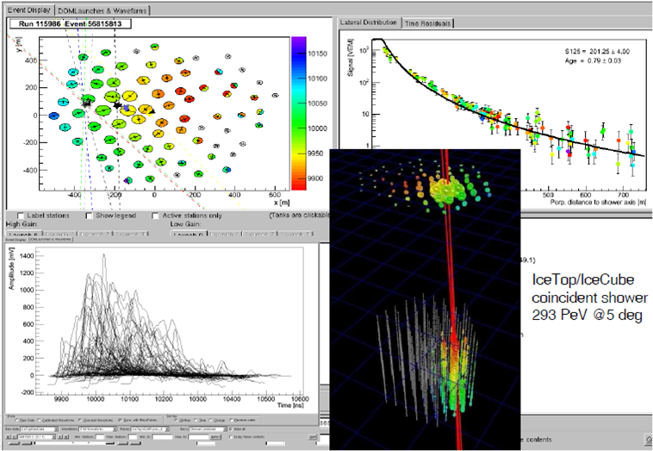

The energy range accessible with IceCube as an air shower detector is 300 TeV to 1 EeV. The lower end of this range includes the knee of the cosmic-ray spectrum. A transition from cosmic rays of galactic origin to a population of particles accelerated at extragalactic sources is expected in the upper range of energy accessible to IceCube. A signature for such a transition would be a change in the relative composition of the primary cosmic ray nuclei. Detectors like Auger and Telescope Array are lowering their thresholds to study this important transition region. The transition is likely to be at the upper end of the energy range of IceCube, which motivates efforts to extend the reach of IceCube by using events with trajectories outside of the IceTop array. The possibility of constructing a larger array on the surface using the radio technique is also being considered.

