Future projects at the South Pole that require deep drilling associated with IceCube.

Executive Summary

Using the 5MW Enhanced hot water drill (EHWD) IceCube has been successful in drilling up to 20 holes in ice to a depth of 2500m. With few exceptions this drill is currently stored in working configurations at the South Pole. Further disposition may depend on anticipated drilling needs in the near future.
Scientists in the IceCube collaboration as well as scientists outside IceCube who work closely with IceCube scientists are currently exploring strategies to leverage on IceCube’s powerful detector infrastructure by augmenting it with additional instrumentation that would both enhance IceCube’s potential and go beyond it’s current science. Two projects are envisioned within the next few years: an 18 string upgrade of IceCube’s Deep Core and a direct detection dark matter detector deployed in the center of IceCube.
Both of these projects would require deep drilling on a scale comparable to IceCube’s drilling requirements. Access to the existing IceCube drill, would vastly facilitate the installation of these instruments and reduce its cost.

2. IceCube Construction and drilling

Major construction of IceCube was completed on December 2010 when the last string was deployed. After 7 years of South Pole drilling operations 86 strings and 162 IceTop tanks were installed and connected to the central data acquisition system in the IceCube Laboratory. A total of 5484 optical sensors were deployed and commissioned.
More than 250 scientists in 36 institutions worldwide are mining the data for a variety of science goals, such as the search for highest energy cosmic neutrinos, dark matter or neutrinos from supernova explosions. More than 30000 atmospheric neutrinos up to 1000 TeV energy are being measured with unprecedented statistics and cosmic rays are measured with new techniques. IceCube’s dense Deep Core central detector measures atmospheric neutrinos at energies down to 10 GeV while the outer IceCube detector provides an effective shield from backgrounds.

The biggest technological challenge for the construction of IceCube was the drilling of 86 holes to a depth 2500m and a diameter of 55cm. A highly trained crew of 30 drillers were able to drill up to 20 holes in a single South Pole construction season using IceCube’s Enhanced Hot Water Drill. The drill provides 5MW of thermal power in form of a high-pressure (1000psi) and high flow (200 gallons/minute) hot water jet to melt ice to a depth of 2500m in 24 hours. The drill consists of about 20 modular structures, some of which (hose reel, drill towers) have been assembled at the South Pole. The only equipment that has left the South Pole to date is the main high-pressure hose (McMurdo for temperature protection) and one of three generators (shipped to continental US for refurbishment). The total weight is about 1 million pounds. This machine which dwarfs any other hot water drill built to date on Earth, is now stored in a winterized condition at the South Pole. The drill will drift in with snow and can be stored for several years without damage to equipment. When needed it can be excavated of the snowdrift. It is estimated qualified personnel that had prior experience with this drill will be able to mobilize the drill to full operational state within 6 to 8 weeks. The drill is a complex machine with more then 300 electronic sensors that are read out by a central computer system. Most of these sensors are relevant for safety and may trigger alarms to the system. Due to its complexity, it is important to keep the entire system together. Loosing even a small fraction of the equipment can make the time for mobilization unpredictably long.
The mobilization of the drill would take about 6 to 8 weeks, little more than the 4 weeks in previous IceCube construction seasons. The mobilization costs for such a drilling campaign are quiet well understood and the “first” drill hole would cost about $2M to $3M including preparations in the North.
The complete construction of a new drill of comparable performance would come at a cost of order $10M and 2 to 3 years of preparation. Intermediate solutions with partial access to existing drill hardware would be anywhere in between.

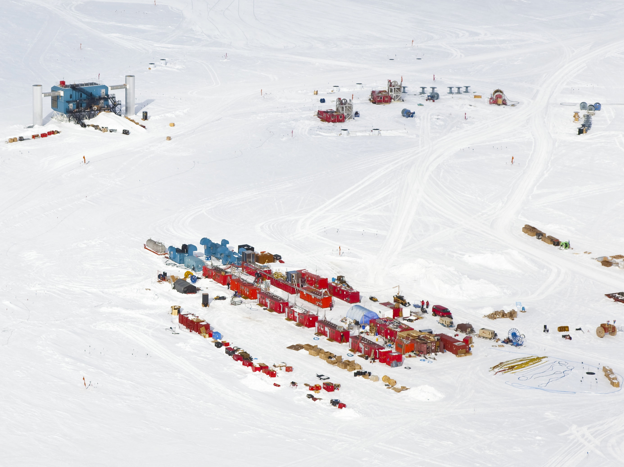
Figure 1: IceCube drill with the main heating plant in the front (seasonal equipment site), the two drill towers and the IceCube laboratory.
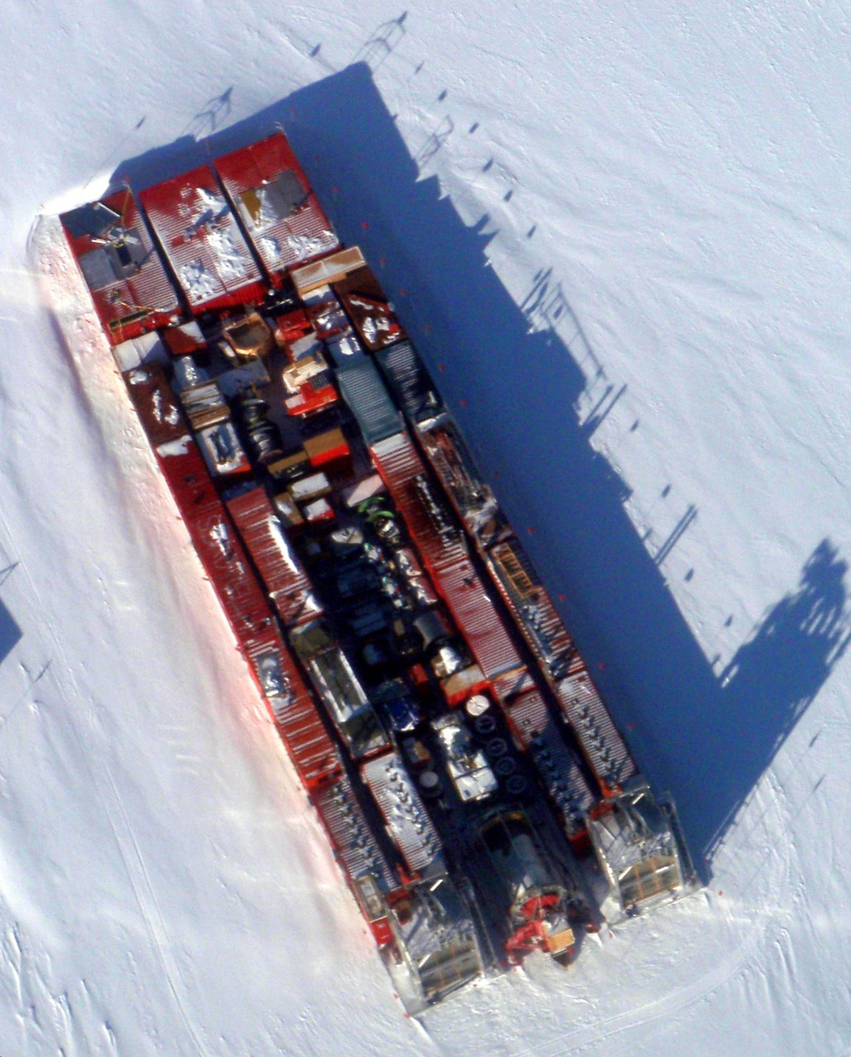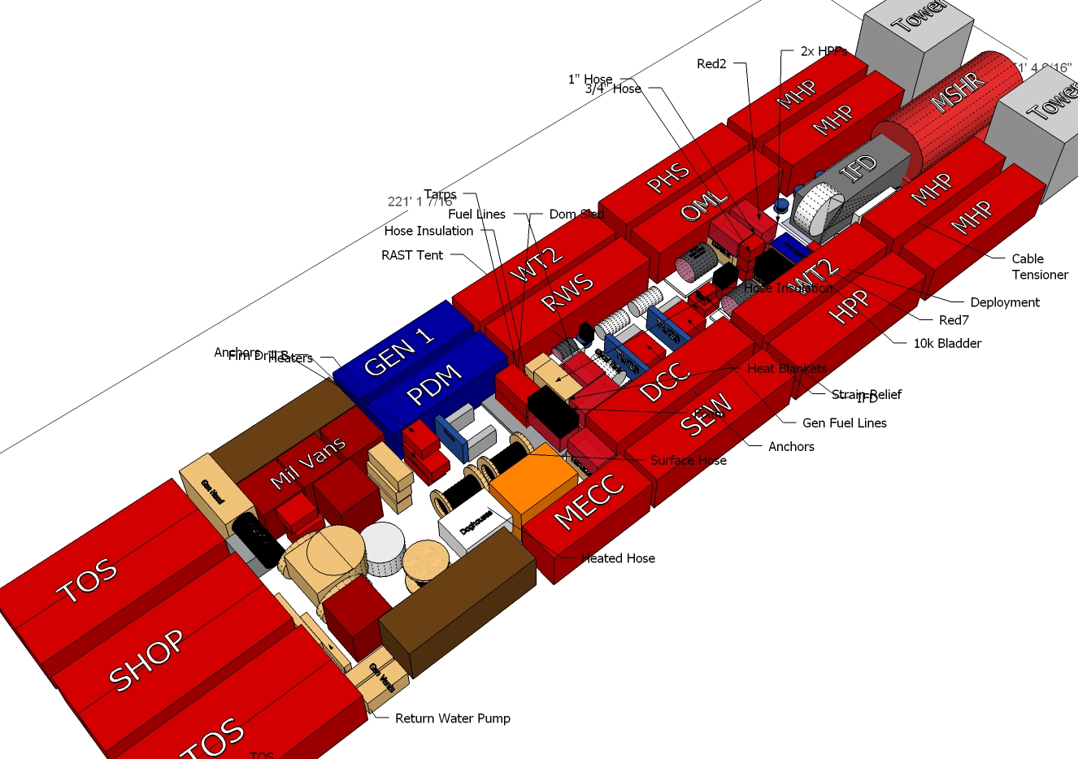

Figure 2: Drill in final winterized condition. Top: areal view, bottom: schematic view. All modules are densely packed. The footprint is about 180’x56’. The position is precisely surveyed so as to allow easy excavation with dozers at a later time.

Future projects I: IceCube 18 string low energy upgrade

Science:
The success of DeepCore, the ~30 megaton, 10 GeV threshold inner subdetector of the IceCube Neutrino Observatory, lies in utilizing the distributed main IceCube in-ice array as a robust active veto against the cosmic ray muons that could mask the neutrino signals of interest from the atmospheric flux, dark matter annihilations and decays, and galactic point sources. The feasibility of a phased infill of the DeepCore detector, with the goal of a precision many-MT particle physics detector, is currently under investigation.

The currently envisioned enhancement will comprise about 18 additional strings of high quantum efficiency digital optical modules at the center of the IceCube, and would aim for a fiducial volume of ~10 Mt with an energy threshold near 1 GeV. Such a detector opens a window to indirect searches for very low-mass Dark Matter, precision measurements of atmospheric neutrino oscillations, improved sensitivity to supernova neutrinos, and first exploration of proton decay searches with a distributed volume detector. While the scientific program of such a detector is clearly rich in its own right, phase 1 would also be a proving ground for the design of a very large scale, high precision neutrino detector in the Antarctic ice. Such a detector has the unique advantage that the fiducial medium is also the support mechanism for the instrument, permitting considerable flexibility in detector geometry with relatively low cost.

Drilling requirements:
The requirements for drilling are very similar to the ones of IceCube.
Depth: 2450m
Diameter of deployed instruments: ~45cm
Number of holes to drill: ~18 (two seasons)

Schedule:
Proposal submission 9-2011 (or spring 2012)
First drilling and construction season: 2013/14 (2014/15)
Second and final drilling and construction season of 10 holes: 2014/15 (2015/16)

Collaboration and cost:
Total cost estimate: 25 to 30M$
The instrumentation hardware of IceCube’s Deep Core was largely funded by international contributions reflecting a strong commitment of collaborating institutions to the sciences. IceCube can look back on a long tradition of proven international partnership and collaboration.
Today, additional prestigious institutions, which are currently members of the European km3Net effort and are not currently members of IceCube have expressed interest in a future upgrade of IceCube. We expect that the funding model of an IceCube upgrade would rely on significant international contributions.
Scientists have already established close contacts and are organizing joint workshops to explore the ground work for an expanded collaboration for an upgrade of IceCube.

Future projects II: dm-ice

DM-Ice: Dark Matter Search at the South Pole

Over the past decade the DAMA/Libra experiment at the Gran Sasso Laboratory (LNGS) in Italy has reported a statistically significant annual modulation in their event rate. The collaboration has interpreted the modulation as an evidence for dark matter. With over 1.17 ton-years of data, DAMA observes a modulation with a significance of 8.9s. More recently, the CoGeNT experiment has reported that they observe more low energy events than expected. CRESST has also observed excess in low energy events, whereas other experiments such as XENON10, XENON100, and CDMS(Si) report null results. It is possible that all the experiments are consistent with existence of light dark matter particles of 5 – 10 GeV, the current picture on the existence of dark matter is far from being clear.

It is fair to state that the DAMA collaboration has not succeeded in convincing the community that the modulation cannot be explained by a systematic effect associated with seasonal variations in the environmental radioactive background, the seasonal variations in the cosmic ray flux or any unidentified systematic associated with season, environment, or temperature. Despite the extensive efforts of the DAMA collaboration to mitigate all systematics, and given the importance of the science, it is essential to repeat the experiment in an entirely different environment.

We propose to build a similar experiment at the South Pole. While most efforts in direct detection focus on better background rejection, we want to do an experiment with better sensitivity to the variation of the signal. The annual modulation of the dark matter particle flux is the same between the northern and southern hemispheres while many of the environmental effects are either reversed or absent. The ice provides the necessary overburden to shield the detectors from cosmic ray. Ice-core and optical measurements indicate that the ice is very clean and radio-pure. While simulations show that background due to direct muon events at this depth is negligible at the current sensitivity levels, IceCube offers an excellent muon veto giving an additional handle on the possible sources of backgrounds. The South Pole Station offers technical and logistical support equal to or exceeding those available at underground laboratories.

During the South Pole summer of 2010/2011, two NaI detectors were deployed along with two of IceCube strings to assess whether it is possible to deploy and operate ultra-low background experiments in the Antarctic Ice using the drilling technology developed for IceCube. The prototype was funded in part by the NSF Antarctic Aeronomy & Astrophysics Program (Proposal# 1046816), University of Wisconsin, and in-kind contributions from the U.K. and Canada. Great care was taken to build a detector that is as clean as possible in the short time we had available to us.

We had a successful detector installation of the two prototypes during the 2010/2011 IceCube construction season. The robustness of the mechanical design of the NaI crystal mounting and the pressure housing has been demonstrated and radioactivity levels of the drill water immediately surrounding the detectors, and the ability to use electronics and data acquisition similar to those used in IceCube are currently being assessed.

The full-scale experiment will consist of 250 kg – 300 kg of NaI crystal detectors equipped with low-background photomultiplier tubes (PMTs). The DAMA experiment consists of 25 crystals of size 10x10x25 cm³ arranged in a 5x5 array to allow for anti-coincidence veto. This arrangement allows them to tag events that occur on the surfaces of the crystals to keep only those events that occur in the bulk of the crystals.

The geometry of the full-scale DM-Ice will be optimized taking into account the unique requirements of this experiment, balancing the linear nature of the geometry of the holes while minimizing the number of pressure vessels to allow for close-packing of several crystals. We envision a detector consisting of several crystals arrays housed in separate pressure vessels of roughly 50 cm in diameter. To take full advantage of the shielding capabilities of the Antarctic ice from cosmic rays, the ice overburden should be as much as possible, between 2000 – 2500 m.

Obtaining NaI crystals with low enough background events will likely be the biggest challenge for this experiment. There are several groups from the U.S. and elsewhere who are making progress in growing such crystals and we plan to work together with those groups to make rapid progress toward achieving this goal. Detector installation during the 2013/2014 austral-summer would give us enough time to produce clean crystals and allow us to make significant impact on the current understanding of dark matter particles.

This is an exciting time for dark matter, with tantalizing results from numerous experiments. An independent verification of the results from DAMA is timely and is a necessary ingredient in the dark matter puzzle that we face today.
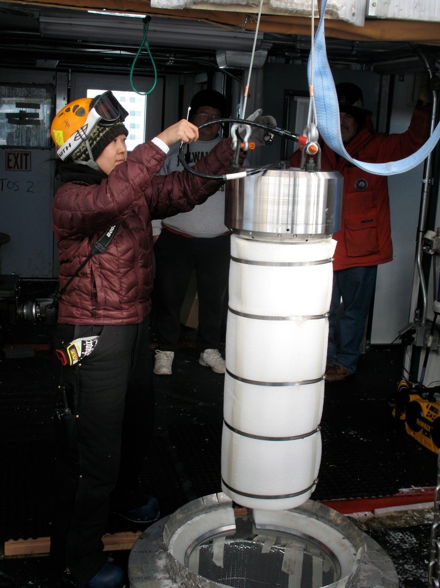
Figure 3: Deployment of the first prototype of dm-ice (December 2010).
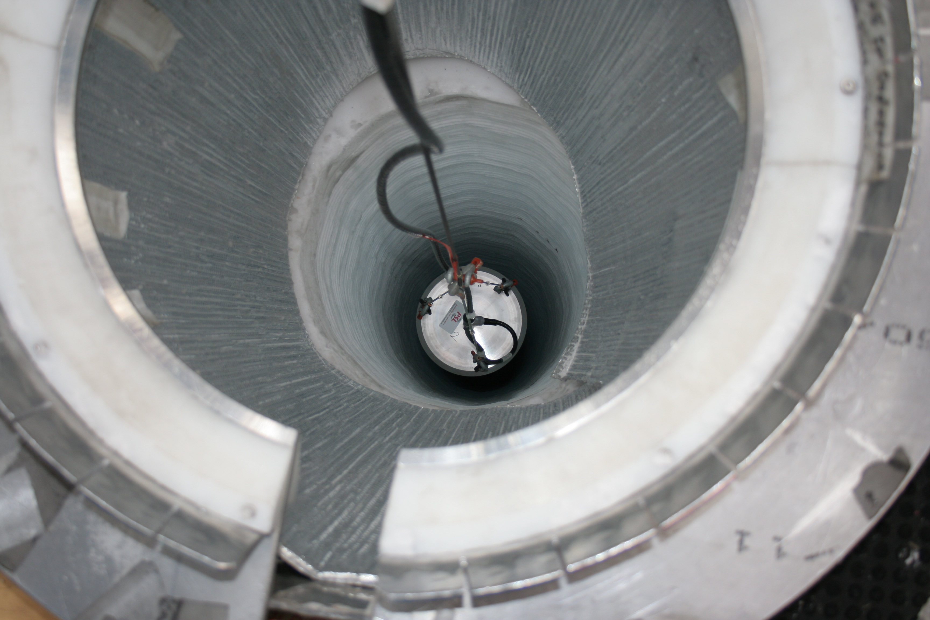
Figure 4: One of the two prototypes being lowered into an IceCube hole.

Drilling requirements:
The requirements for drilling are less stringent and offer more flexibility than for IceCube.
Depth: ideally 2450m, shallower depth up to 2100 m is possible.
Diameter of deployed instruments: ~35cm minimum, up to 70 cm may be useful
Number of holes to drill: 2 to 4 holes
The instruments can be co-deployed with future IceCube upgrade holes as was done for the prototype deployments.

Schedule:
Proposal submission fall 2011 (or spring 2012)
Drilling and deployment season: 2013/14 or 2014/15

Collaboration and cost:
Total cost estimate: 8 - 10M$
Several institutions including international groups outside of the existing IceCube collaboration have expressed strong interest in collaboration. The detection technology as well as the readout is more independent of IceCube. Also the veto requirements are more localized and simpler than for the generic low energy neutrino physics with Deep Core.

Future projects III: IceCube high energy or other upgrades

While two very specific projects have emerged as likely upgrade candidates, we should keep in mind that IceCube is a discovery instrument, that will only now start operating at its full sensitivity and that 79 string data from 2010 have not yet been unblinded. A possible discovery in a specific channel, from high-energy astrophysical neutrinos, neutrino physics beyond the standard model, to dark matter, or supernova – a discovery in any of these channels would create new realities that could change the upgrade plans.

